Module 1:

Data Analysis with Python
Python is one of the top programming languages for data science, and now that you know how to program with Python, you will learn to use it for analyzing data.

Key Python Libraries for Data Analysis
In this course, you will work with essential Python libraries widely used in industries like healthcare, finance, insurance, and technology:
- NumPy
- Pandas
- scikit-learn (sklearn)
These libraries are fundamental for data analysis, machine learning, and building data pipelines.

Course Modules
The course is divided into multiple modules, each focusing on different aspects of data analysis and machine learning.

Module 1: Data Understanding and Importing
- Understanding dataset characteristics
- Overview of Python packages for data analysis
- Importing and exploring data

Module 2: Data Wrangling and Preprocessing
- Handling missing values
- Data formatting
- Data normalization

Module 3: Exploratory Data Analysis (EDA)
- Descriptive statistics
- GroupBy operations
- Correlation analysis
- Key statistical methods for data insights

Module 4: Regression and Model Evaluation
- Linear regression
- Polynomial regression
- Pipeline creation
- In-sample evaluation measures
- Prediction and decision making

Module 5: Model Refinement and Optimization
- Model evaluation
- Overfitting and underfitting
- Model selection techniques
- Ridge regression
- Grid search for hyperparameter tuning

Hands-On Project
At the end of the course, you will apply your skills to a real-world dataset through a hands-on project, giving you practical experience in data analysis and machine learning.

Prerequisites
To get the most out of this course, you should have:
- Basic Python programming knowledge
- High school level mathematics

Data Analysis with Python: Used Car Prices Dataset

Introduction to the Dataset
The dataset on used car prices, created by Jeffrey C. Schlimmer, is provided in CSV format, where each value is separated by commas for easy import into most tools and applications. Each line represents a row in the dataset.

Dataset Structure
- Typically, the first row contains column headers, but in this dataset, it is simply another row of data.
- The dataset has 26 columns, each describing a specific attribute of cars.

Understanding the Attributes
Key attributes include:

Symboling
- Represents the insurance risk level of a car.
- Cars receive an initial risk factor based on price, which can be adjusted:
  - +3: High risk
  - -3: Low risk / Safe

Normalized Losses
- Measures the relative average loss payment per insured vehicle year.
- Normalized across cars of specific size categories (e.g., two-door small cars, station wagons, sports cars).
- Values range from 65 to 256.

Additional Attributes
- Includes variables such as make, fuel type, engine size, and many others.
- Full details are available in the course documentation.

Target Variable
The 26th attribute is price, which serves as the target variable or label. All other attributes, such as symboling, normalized losses, and make, act as predictors.

Goal of the Project
The objective is to predict car prices using the dataset’s attributes. Although the data is from 1985 and prices may seem outdated, the primary aim is to practice and learn data analysis techniques.

Data Analysis in Python: Key Libraries

Introduction to Python Data Analysis Libraries
To perform data analysis in Python, it is essential to understand the main packages relevant to analysis. A Python library is a collection of functions and methods that allow you to perform tasks without writing code from scratch. These libraries come with built-in modules providing different functionalities that can be used directly.
Python data analysis libraries can be grouped into three major categories:

Scientific Computing Libraries

Pandas
- Provides data structures and tools for effective data manipulation and analysis.
- Primary structure: DataFrame, a two-dimensional table with labeled rows and columns.
- Offers fast access to structured data and easy indexing functionality.

NumPy
- Uses arrays for input and output.
- Can be extended to matrices with minimal coding changes.
- Enables fast array processing for numerical computations.

SciPy
- Includes functions for advanced mathematical problems.
- Supports data visualization methods for effective communication of analytical results.

Data Visualization Libraries

Matplotlib
- Most well-known library for creating graphs and plots.
- Highly customizable for various visualization needs.

Seaborn
- Built on top of Matplotlib.
- Simplifies creation of heat maps, time series plots, violin plots, and more.

Machine Learning and Statistical Modeling Libraries

Scikit-learn
- Provides tools for statistical modeling such as regression, classification, and clustering.
- Built on top of NumPy, SciPy, and Matplotlib.

Statsmodels
- Used for exploring data, estimating statistical models, and performing statistical tests.

Reading Data Using Pandas

Introduction
In this section, you will learn how to read data into Python using the Pandas package. Once the data is loaded, you can perform various data analysis tasks efficiently.

Data Acquisition Process
Data acquisition involves loading and reading data into a Python notebook from different sources. Two important factors influence this process:

Data Format
- Format specifies how data is encoded.
- Common formats include CSV, JSON, XLSX, and HDF.
- File format is often determined by the file extension.

File Path
- Indicates the location of the data.
- Data can be stored locally on your computer or online.

Example: Used Car Dataset
- A dataset of used cars is available online.
- Data points are separated by commas, indicating a CSV (Comma-Separated Values) format.

Reading Data into Pandas
You can read data in Pandas in just three steps:
- Import the Pandas library.
- Define a file path variable.
- Use the read_csv() method to load the data into a DataFrame.

Handling Missing Column Headers
- If the data has no headers, set header=None in the read_csv() method.
- Pandas will assign default integer column names.

Exploring the Data
- Use dataframe.head() to display the first n rows.
- Use dataframe.tail() to display the last n rows.
- These methods help confirm that the data has been loaded correctly.

Assigning Column Names
- Column names can be loaded from a separate file or list.
- Example:
- headers = ["col1", "col2", "col3"]
- df.columns = headers
- After assigning headers, use head() to verify the update.

Exporting Data
- Use to_csv() to save a DataFrame to a CSV file.
- Example:
- df.to_csv("automobile.csv")
- Pandas supports many other file formats with similar syntax.
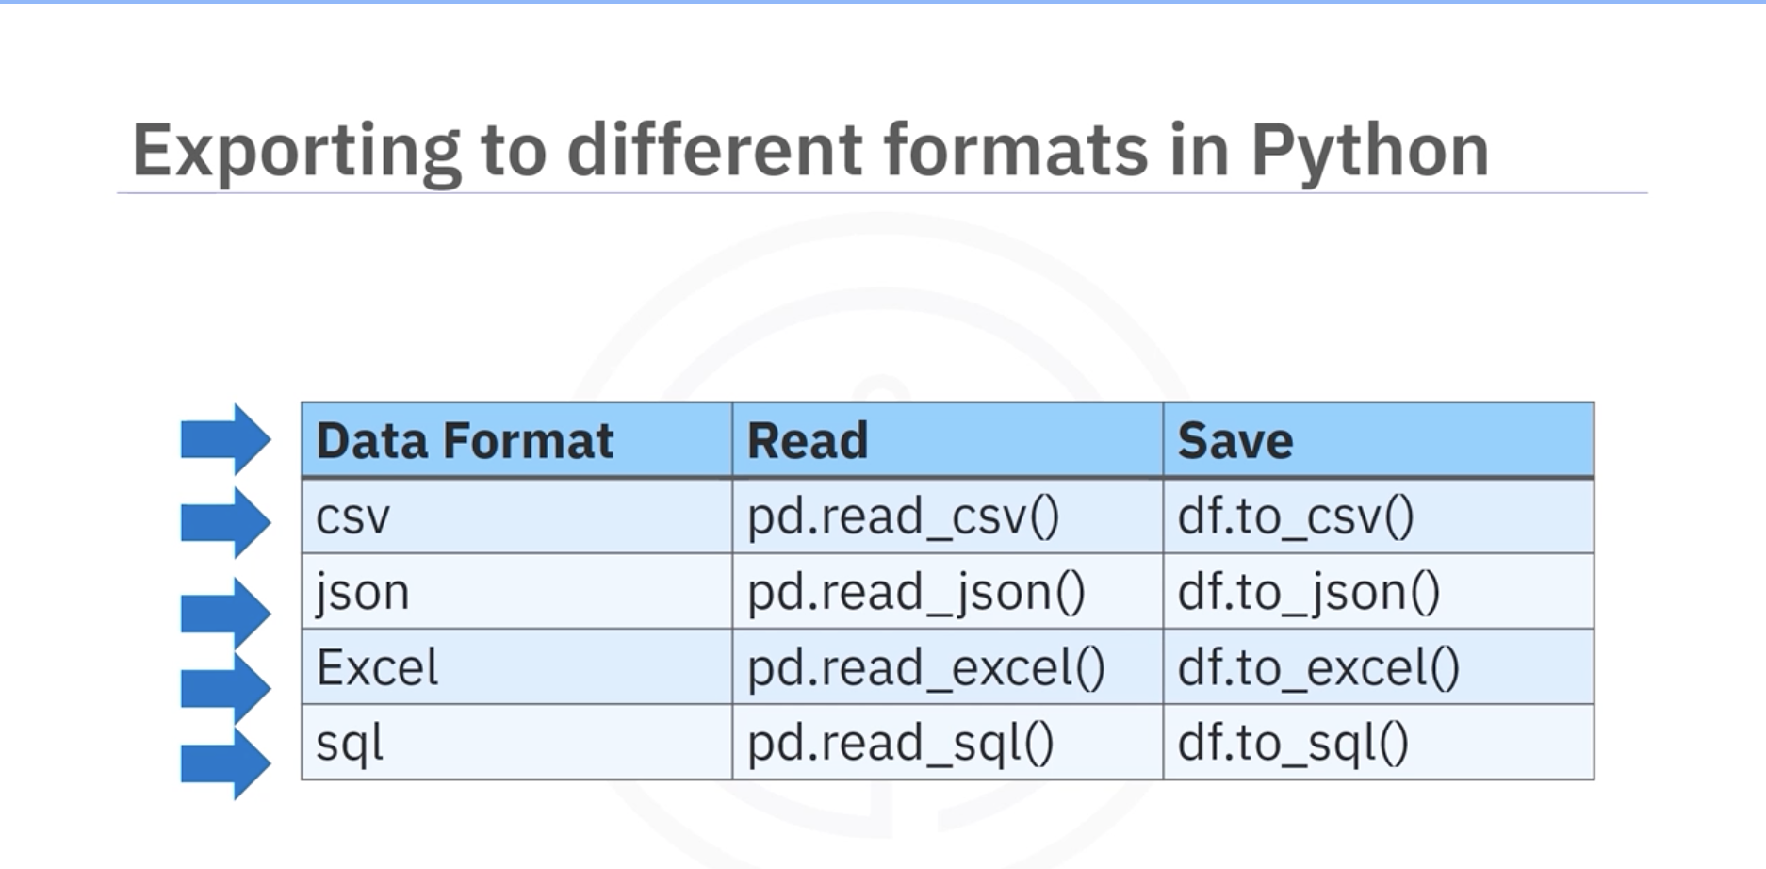

Summary
- Pandas makes it easy to load, explore, and export data.
- Key methods: read_csv(), head(), tail(), to_csv().
- You can work with various formats, but CSV is the most commonly used in this course.

Types of Data

Introduction
Data can be categorized into two main types:
- Qualitative Data
- Quantitative Data

Qualitative or Categorical Data
Qualitative or Categorical Data refers to information that cannot be measured or counted in numerical form. Instead, it is classified by categories or characteristics such as gender, color, or opinions.
These data types consist of text, symbols, audio, or images and are useful in understanding perceptions or preferences. For example, the gender of a person (male, female, or others) is qualitative data. Market researchers use this type of data to understand customers’ tastes and design their strategies accordingly.

Examples of Qualitative Data
- Language spoken
- Favorite holiday destination
- Opinion (agree, disagree, or neutral)
- Colors

Classification of Qualitative Data
Qualitative data is further divided into two types:
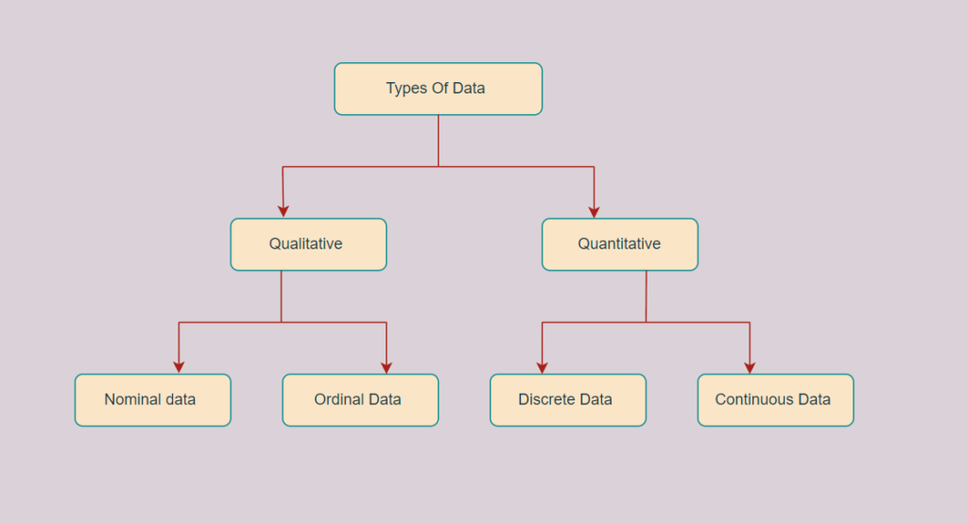

A. Nominal Data
Nominal data is used to label variables without assigning any order or quantitative value. It is purely categorical and cannot be compared or ranked. The word “nominal” comes from the Latin term nomen, meaning “name.”

Examples of Nominal Data
- Hair color (Blonde, Red, Brown, Black)
- Marital status (Single, Married, Widowed)
- Nationality (Indian, German, American)
- Gender (Male, Female, Others)
- Eye color (Black, Brown)

B. Ordinal Data
Ordinal data has a meaningful order or ranking but lacks precise numerical differences between ranks. It is qualitative data with relative positioning.
Ordinal data is often used in surveys or observations like customer satisfaction or educational level. While ordinal data can be ordered, arithmetic operations cannot be performed on it.

Examples of Ordinal Data
- Feedback or satisfaction scale (1 to 10)
- Letter grades (A, B, C, D)
- Ranking in a competition (First, Second, Third)
- Economic status (High, Medium, Low)
- Education level (Primary, Secondary, Higher)

Difference between Nominal and Ordinal Dat
Nominal Data | Ordinal Data
Cannot be quantified or ordered | Have a meaningful order or sequence
Purely qualitative | Between qualitative and quantitative
No arithmetic operations possible | Numbers can be assigned but no arithmetic operations allowed
Cannot compare categories | Allows comparison by ranking
Examples: Eye color, gender, hair color | Examples: Education level, satisfaction rating

Quantitative Data
Quantitative data is expressed numerically and can be measured, counted, and statistically analyzed. It answers questions like how much, how many, and how often. Examples include height, weight, time, or income.
Quantitative data is represented using visual formats like bar graphs, histograms, scatter plots, or line charts.

Examples of Quantitative Data
- Height or weight of a person
- Room temperature
- Scores or marks (e.g., 59, 80, 60)
- Time

Classification of Quantitative Data
Quantitative data is further classified into two types:

A. Discrete Data/Numerica Data
Discrete data includes countable and distinct values, usually whole numbers or integers. These data cannot take decimal values. For example, the number of students in a class is discrete.

Examples of Discrete Data
- Number of students in a class
- Cost of a mobile phone
- Number of employees in a company
- Number of players in a competition
- Days in a week

B. Continuous Data
Continuous data can take any value within a range, including fractions and decimals. It represents measurements that can be infinitely subdivided, such as temperature or height.

Examples of Continuous Data
- Height of a person
- Speed of a vehicle
- Time taken to complete a task
- Wi-Fi frequency
- Market share price

Difference between Discrete and Continuous Data
Discrete Data | Continuous Data
Countable and finite; whole numbers | Measurable; includes fractions or decimals
Represented by bar graphs | Represented by histograms
Cannot be subdivided | Can be subdivided into smaller units
Has gaps between values | Continuous and without gaps
Examples: Number of students, days in a week | Examples: Temperature, height, weight

Exploring Data Using Pandas

Introduction
In this section, we introduce essential Pandas methods that data scientists and analysts should know when exploring a dataset in Python. We assume the data has already been loaded, and now we focus on exploring its structure and summary.

Understanding Data Types
Pandas provides built-in methods to check data types and understand the distribution of data. This helps identify potential issues, such as columns assigned the wrong data type.

Common Data Types in Pandas
- objects: Similar to strings in Python.
- float: For continuous numeric values.
- int: For integer numeric values.
- datetime: For time series data.
Pandas automatically assigns data types based on the source data, but these assignments may sometimes be incorrect.

Why Check Data Types?
- Detect Incorrect Assignments: For example, a column like car price should be numeric, but it might be assigned as an object type.
- Function Compatibility: Certain Python functions, especially mathematical ones, work only with numeric data.

Viewing Data Types
- Use the dataframe.dtypes method to view each column's data type.
- This helps spot mismatches early in the analysis process.

Statistical Summary of Data
To understand data distribution, Pandas provides the describe() method.

Default Behavior
- Returns statistics like count, mean, standard deviation (STD), min, max, and quartiles.
- By default, only numeric columns are summarized.

Including All Columns
- Use dataframe.describe(include="all") to summarize all columns, including objects.
- For object columns, metrics include:
  - unique: Number of distinct objects
  - top: Most frequent object
  - freq: Frequency of the top object

Summary Parameters in the Output
- count
  - Number of non-missing (non-NaN) values in that column.
  - Example: 201 means there are 201 valid entries.
- unique (for categorical data only)
  - Number of unique/distinct values in the column.
  - Example: 186 means there are 186 unique price values.
- top (for categorical data only)
  - The most frequent value (mode) in that column.
  - Example: 16500 means this value appears the most times.
- freq (for categorical data only)
  - Frequency (count) of the most frequent value.
  - Example: 2 means 16500 appeared twice.
- mean (for numeric data only)
  - The average value of the column.
  - Example: 0.840796 is the mean for symboling.
- std (for numeric data only)
  - Standard deviation → shows how spread out the data is.
  - Example: 1.254802 → larger std = more spread out.
- min (for numeric data only)
  - The minimum value in the column.
  - Example: -2.000000 is the lowest symboling value.
- 25%, 50%, 75% (for numeric data only)
  - These are percentiles:
    - 25% → value below which 25% of data falls
    - 50% → median (middle value)
    - 75% → value below which 75% of data falls
- max (for numeric data only)
  - The maximum value in the column.
  - Example: 3.000000 is the highest symboling value.
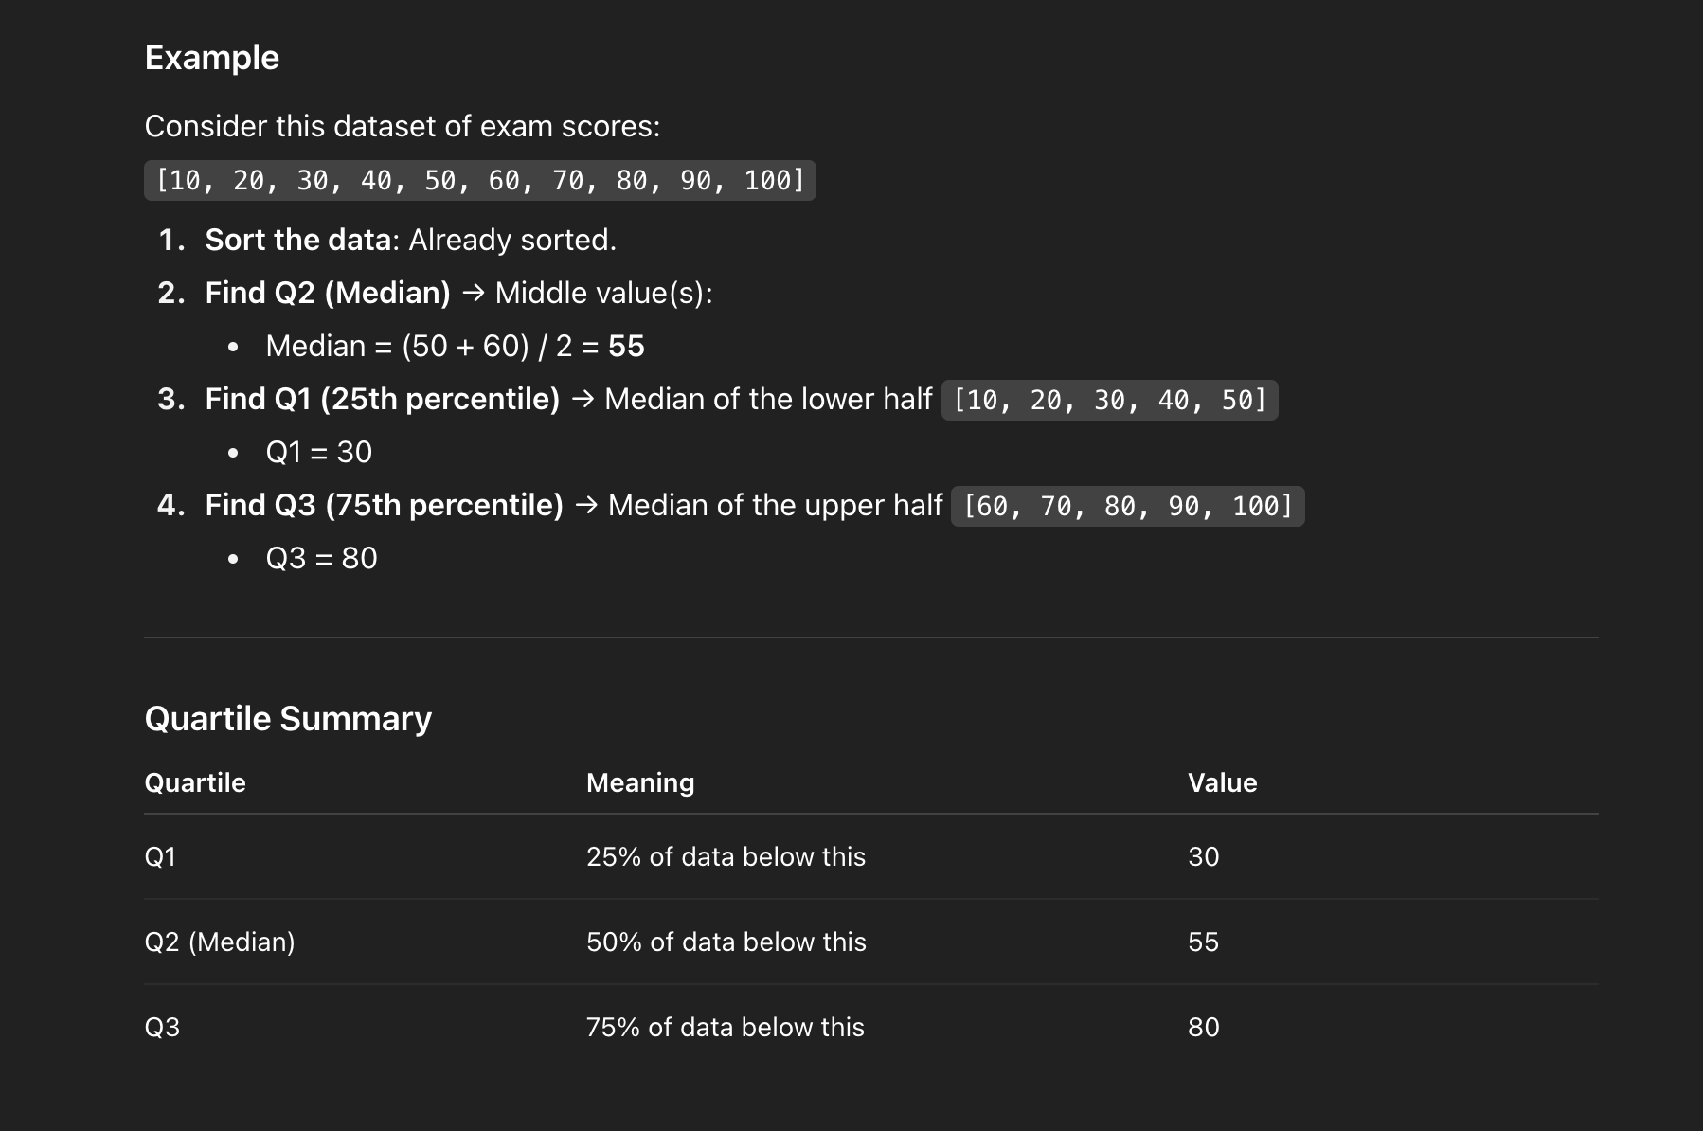

Handling Missing Values
- Some statistics may return NaN (Not a Number) if the metric does not apply to a column's data type.

Dataset Information
The dataframe.info() method provides a concise summary, including:
- Column names
- Data types
- Non-null counts
- Memory usage

Summary
- Use dtypes to check data types.
- Use describe() for statistical summaries.
- Use info() for a quick overview of the dataset structure.

Accessing Databases Using Python

Introduction
In this section, we learn how to access databases using Python, a critical skill for data scientists. By the end, you will understand how Python communicates with database systems using APIs and how to perform basic operations.

Connecting to Databases
Python programs communicate with Database Management Systems (DBMS) using API calls. A common environment for writing this code is Jupyter Notebook, a web-based editor.

SQL APIs
- Definition: An Application Programming Interface (API) is a set of functions used to access services.
- SQL API: Provides functions to send SQL statements to a DBMS and retrieve results.
- Typical Flow:
  - Connect to the DBMS using API calls.
  - Build SQL statements as text strings.
  - Pass SQL commands to the DBMS via API functions.
  - Retrieve query results and status information.
  - Handle errors if any occur.

Ending Database Connections
- After completing operations, an API call disconnects the application from the database, ensuring proper resource management.

Python DB API
Python provides a standard API, known as DB API, for accessing relational databases.

Key Advantages
- Write one program that works with multiple relational databases.
- Learn DB API functions once, then apply to any database system.

Core Concepts
- Connection Objects: Used to connect to the database and manage transactions.
- Cursor Objects: Used to execute queries and retrieve results.

Working with Cursors
A cursor works like a text cursor, scanning through the query results.

Cursor Methods
- cursor(): Creates a new cursor object from a connection.
- execute(): Runs SQL queries.
- fetch(): Retrieves query results.
- commit(): Saves any pending transaction.
- rollback(): Reverts the database to the state before the transaction.
- close(): Closes the cursor or connection.
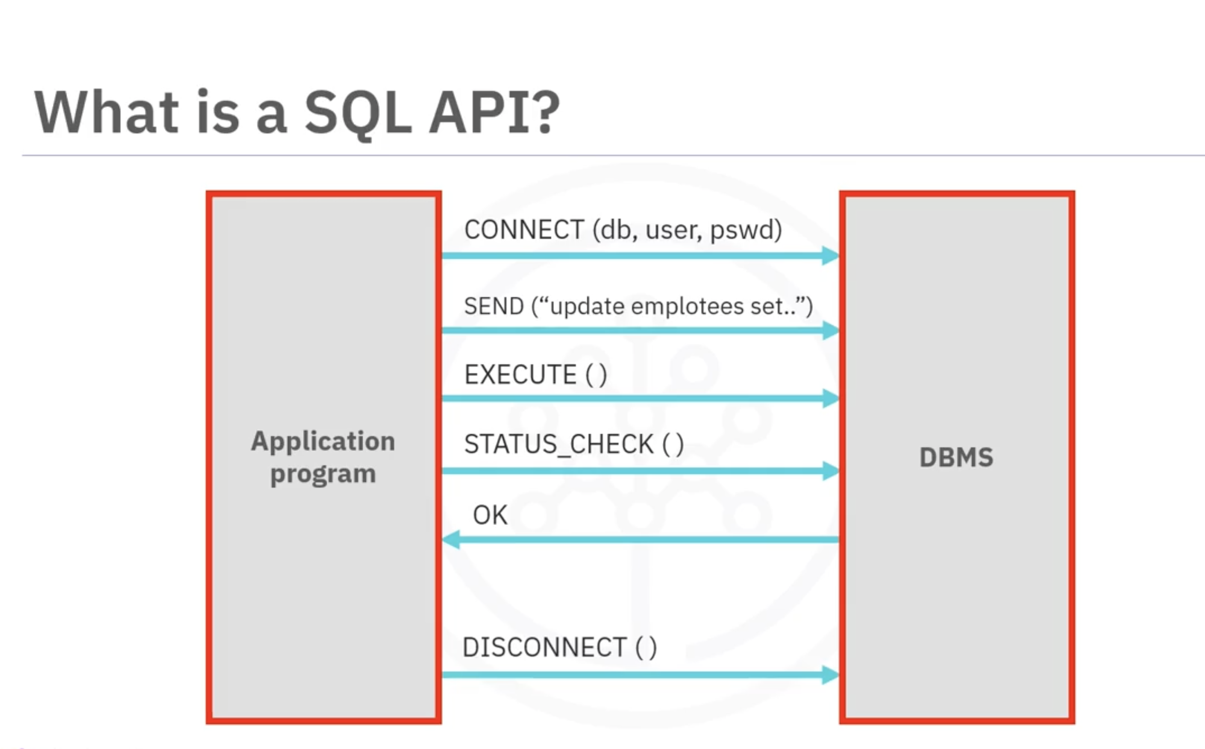

Sample Workflow in Python
- Import Database Module: Import the appropriate database library.
- Establish Connection: Use the connect() function with parameters like database name, username, and password.
- Create Cursor: Generate a cursor object from the connection.
- Execute Queries: Run SQL statements using the cursor.
- Fetch Results: Retrieve and process query results.
- Close Connection: Release resources by closing the connection after completion.
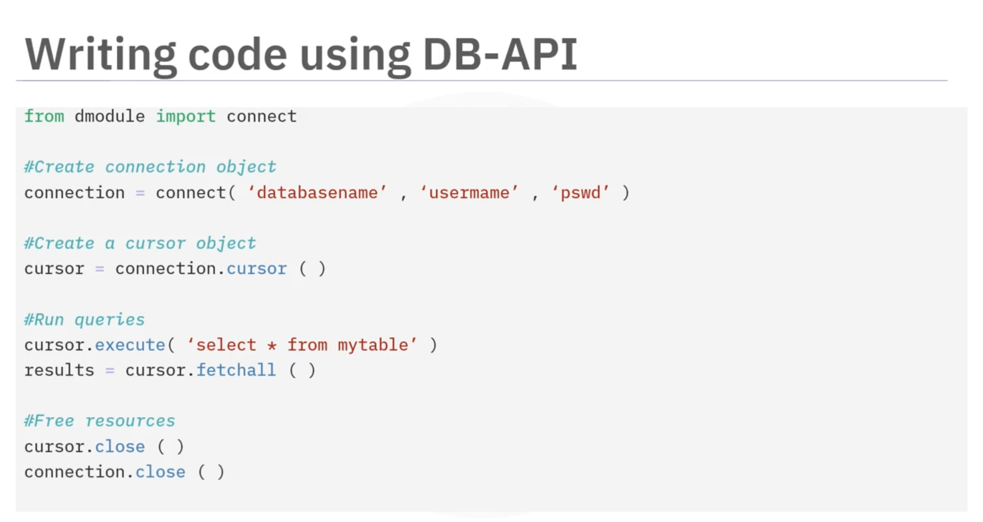

Summary
- Python connects to databases using API calls, primarily through the DB API.
- Connection objects handle transactions; cursor objects manage queries.
- Properly closing connections prevents resource wastage.

Lesson Summary

Key Concepts Learned
At this point in the course, you should understand the following concepts:

Dataset Structure
- Each line in a dataset is a row, and commas separate the values.
- Analyze the attributes for each column to understand the data better.

Python Libraries
- Libraries are collections of functions and methods that simplify programming tasks.
- Categories include:
  - Scientific Computing
  - Data Visualization
  - Machine Learning Algorithms
- Many libraries are interconnected; for example, Scikit-learn is built on top of NumPy, SciPy, and Matplotlib.

Data Handling with Pandas
- Data format and file path are key factors for reading data.
- The read_csv() method loads CSV files into a Pandas DataFrame.
- Pandas has unique data types: object, float, int, and datetime.
- Use dtype to check each column’s data type; misclassified types may need correction.
- Correct data types allow appropriate Python functions to be applied to columns.

Statistical Analysis
- The describe() method provides count, mean, standard deviation, min, max, and quartile ranges for numerical columns.
- Use include='all' to get summaries for object-type columns.
- Statistical summaries help detect potential issues such as outliers.
- The info() method gives an overview of the DataFrame, including top and bottom rows.
- NaN indicates missing values, preventing some statistics from being calculated.

Database Connectivity with Python
- Python connects to databases via SQL APIs or DB APIs.
- SQL APIs: Build SQL queries as text strings, send them to the DBMS, and retrieve results.
- DB API: Python's standard for interacting with relational databases using:
  - Connection objects: Establish/manage connections and transactions.
  - Cursor objects: Run queries and navigate results.
- Connection methods include cursor(), commit(), rollback(), and close().
- Always close the database connection after use to free resources.

Overview: Laptop Pricing Data Set
The dataset used for this practice exercise is a modified subset that maps the price of laptops with different attributes.
The dataset is a filtered and modified version of the Laptop Price Prediction using Specifications dataset on the Kaggle website.

Parameters

Manufacturer
The company that manufactured the laptop.

Category
The category to which the laptop belongs. This parameter is mapped to numerical values as follows:
Category | Assigned Value
Gaming | 1
Netbook | 2
Notebook | 3
Ultrabook | 4
Workstation | 5

GPU
The manufacturer of the GPU. This parameter is mapped to numerical values as follows:
GPU | Assigned Value
AMD | 1
Intel | 2
NVidia | 3

OS
The operating system type (Windows or Linux). This parameter is mapped to numerical values as follows:
OS | Assigned Value
Windows | 1
Linux | 2

CPU_core
The type of processor used in the laptop. This parameter is mapped to numerical values as follows:
CPU_core | Assigned Value
Intel Pentium i3 | 3
Intel Pentium i5 | 5
Intel Pentium i7 | 7

Screen_Size_cm
The size of the laptop screen, measured in centimeters (cm).

CPU_frequency
The frequency at which the CPU operates, measured in gigahertz (GHz).

RAM_GB
The size of the laptop’s RAM, measured in gigabytes (GB).

Storage_GB_SSD
The size of the SSD storage, measured in gigabytes (GB).

Weight_kg
The weight of the laptop, measured in kilograms (kg).

Price
The price of the laptop, measured in US Dollars (USD).

Module 2:

Data Pre-Processing Techniques

Introduction to Data Pre-Processing
Data pre-processing is an essential step in data analysis. It involves converting or mapping raw data into a format suitable for further analysis. This step is also known as data cleaning or data wrangling.

Topics Covered in This Module

Handling Missing Values
- Missing values occur when data entries are left empty.
- We'll explore techniques to identify and handle missing data effectively.

Data Formatting
- Data from different sources may come in various formats, units, or conventions.
- We'll introduce Python Pandas methods to standardize these values into consistent formats for better analysis.

Data Normalization
- Numerical data columns may have very different ranges, making direct comparisons challenging.
- Normalization brings all data into a similar range for meaningful comparisons.
- Techniques covered include centering and scaling.

Data Binning
- Binning converts a set of numerical values into larger categories.
- It is particularly useful for comparisons between groups of data.

Categorical Variables
- Categorical values often need conversion into numeric variables for statistical modeling.
- We'll show how to perform this conversion in Python.

Working with Data in Python
- Operations are often performed along columns, with each row representing a sample.
- Access columns using their names, e.g., symboling or body style.

Manipulating Data Frames
- Each column in a DataFrame is a Pandas Series.
- Example: Adding a value to each entry in a column.
  - To add 1 to each symboling entry:
  - df["symboling"] = df["symboling"] + 1
- This command updates each value in the column by adding one to the current value.

Handling Missing Values in Data

Introduction to Missing Values
Missing values occur when no data value is stored for a feature in a particular observation. These can appear as question marks, N/A, zero, blank cells, or NaN. Missing data is a common issue across all tools and platforms, including Python and R.

Strategies to Handle Missing Values

Checking Data Sources
- Confirm whether the missing values can be retrieved by contacting the data collector.

Dropping Missing Data
- Drop Rows: Remove rows containing missing values if they are few and non-critical.
- Drop Columns: Remove entire variables if too many values are missing.
- Use Pandas dropna() method:
- df.dropna(subset=["price"], axis=0, inplace=True)

Replacing Missing Data
- Numerical Data: Replace missing values with the mean of the column.
- mean_value = df["normalized-losses"].mean()
- df["normalized-losses"].replace(np.nan, mean_value, inplace=True)
- Categorical Data: Use the most frequent value (mode) for replacement.

Advanced Replacement Techniques
- Replace values using group means or additional known information.
- Keep data missing if it holds analytical value.

Methods in Python for Missing Values

Dropping Data
- Use dropna() with axis=0 to drop rows or axis=1 to drop columns.
- Set inplace=True to update the original DataFrame.

Replacing Data
- Use replace() to fill missing values with calculated or known values.
- Commonly replaced with mean, median, or mode depending on data type.

Summary
- Identify missing values and decide whether to drop or replace them.
- Use dropna() for removal and replace() for substitution in Python.
- Consider data quality, analysis goals, and data context before choosing the method.

Handling Data with Different Formats and Units

Introduction to Data Formatting
Data collected from multiple sources often comes in different formats, units, and conventions. Data formatting involves bringing this data into a common standard to make meaningful comparisons and ensure consistency for analysis.

Importance of Data Formatting
- Ensures consistency and clarity in datasets.
- Helps in accurate statistical analysis.
- Reduces errors caused by varied data representations.
For example, the city name "New York" might appear as N.Y., Ny, NY, or New York. Depending on the analysis goal, this variation might be useful (e.g., for detecting fraud) or might need to be standardized.

Converting Units in Data
In some cases, datasets use units that may not be convenient for all users. For example:
- The feature city-miles per gallon represents fuel consumption in miles per gallon.
- Some users may want to convert this to liters per 100 kilometers, the metric unit.

Conversion Formula
To convert miles per gallon to liters per 100 kilometers:
liters_per_100km = 235 / miles_per_gallon
This can be done in Python with one line of code.

Renaming Columns
After conversion, rename the column using the DataFrame rename method for clarity.

Handling Data Types
Sometimes datasets import with incorrect data types:
- Example: The price column may import as an object instead of int or float.

Identifying Data Types
- Use dataframe.dtypes to check each feature’s data type.

Converting Data Types
- Use dataframe.astype() to convert columns:
df["price"] = df["price"].astype("int")

Common Data Types in Pandas
- Object: Letters or words.
- Int64: Integer numbers.
- Float: Real numbers with decimals.

Summary
- Standardize data formats for consistency.
- Convert units when necessary for analysis convenience.
- Check and correct data types to ensure accurate results in further analysis.

Data Normalization

Introduction to Data Normalization
Data normalization is an important technique in data preprocessing. It ensures that different features have consistent ranges, allowing fair comparisons and improving statistical analysis accuracy.

Importance of Normalization
- Makes variable ranges consistent.
- Enables fair comparisons between features.
- Prevents certain attributes from dominating models due to larger value ranges.
- Improves computational efficiency.

Examples of Normalization
Consider the following examples:
- Used Car Dataset: The feature length ranges from 150 to 250, while the width and height range from 50 to 100. Without normalization, features with larger ranges could dominate analyses.
- Age and Income Dataset: Age ranges from 0 to 100, while income ranges from 20,000 to 500,000. Income would heavily influence models like linear regression due to its larger numerical values, even if it is not more important.

Methods of Normalization
There are three commonly used normalization methods:

Simple Feature Scaling
- Formula:
x_new = x_old / max(x)
- Divides each feature value by the maximum value, resulting in values between 0 and 1.

Min-Max Method
- Formula:
x_new = (x_old - min(x)) / (max(x) - min(x))
- Subtracts the minimum value and divides by the range, scaling values between 0 and 1.

Z-Score Method (Standard Score)
- Formula:
z = (x_old - μ) / σ
- Subtracts the mean (μ) and divides by the standard deviation (σ).
- Produces values typically between -3 and 3.

Applying Normalization in Python
Using the length feature as an example:
- Simple Feature Scaling: Divide each value by the maximum using df['length'].max().
- Min-Max Method: Subtract the minimum and divide by the range (max - min).
- Z-Score Method: Subtract the mean and divide by the standard deviation using mean() and std() methods.

Summary
- Normalization ensures fair comparisons between features.
- It prevents numerical dominance of certain variables.
- Three main methods: Simple Feature Scaling, Min-Max, and Z-Score.
- Normalization is easily implemented in Python using Pandas methods.

Binning in Data Preprocessing

Introduction to Binning
Binning is a data preprocessing technique where numerical values are grouped into discrete intervals or "bins." This process helps simplify data, improve model accuracy, and provide a clearer understanding of data distribution.

Importance of Binning
- Group numerical values into fewer categories.
- Simplifies data interpretation.
- Can improve the accuracy of predictive models.
- Useful for visualizing data distribution.

Example: Binning Car Price Data
Consider a dataset with the attribute price ranging from 5,188 to 45,400, containing 201 unique values. We can categorize the prices into three bins:
- Low Price
- Medium Price
- High Price

Creating Equal-Width Bins
To create three bins with equal width, we need four numbers equally spaced across the price range. Using Python:
- NumPy's linspace function generates equally spaced dividers.
- Group Names: A list like ["Low", "Medium", "High"] labels each bin.

Applying Binning in Python
- Use Pandas' cut function to segment data values into bins.
- Visualize the data using histograms to show how many values fall into each bin.
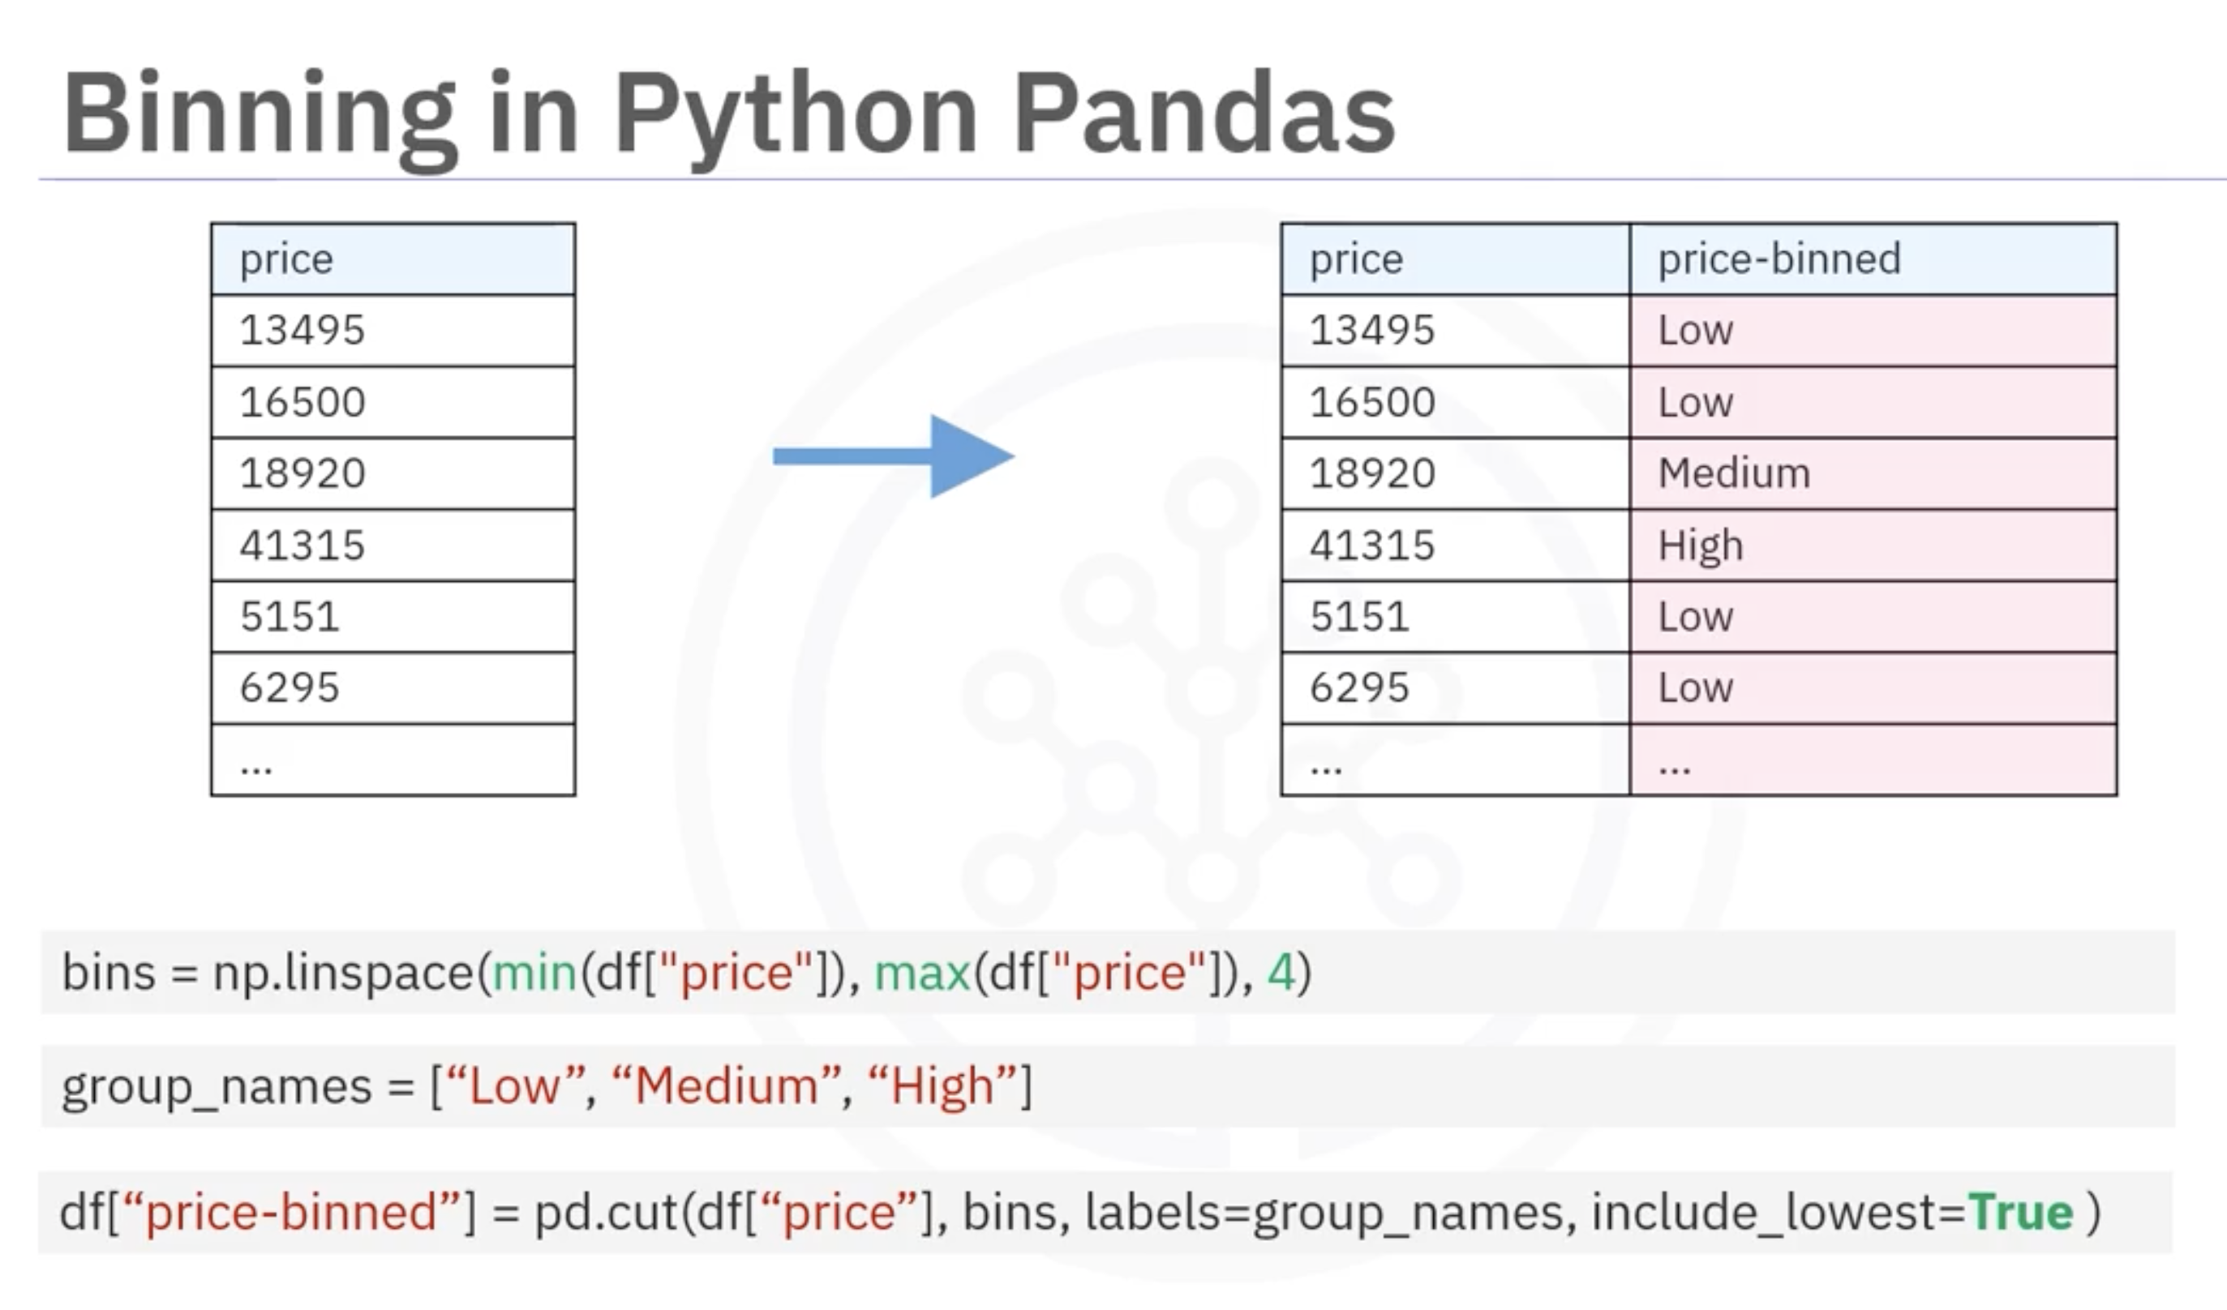

Insights from the Histogram
From the resulting plot:
- Most cars fall into the low price category.
- Only a few cars have high prices.
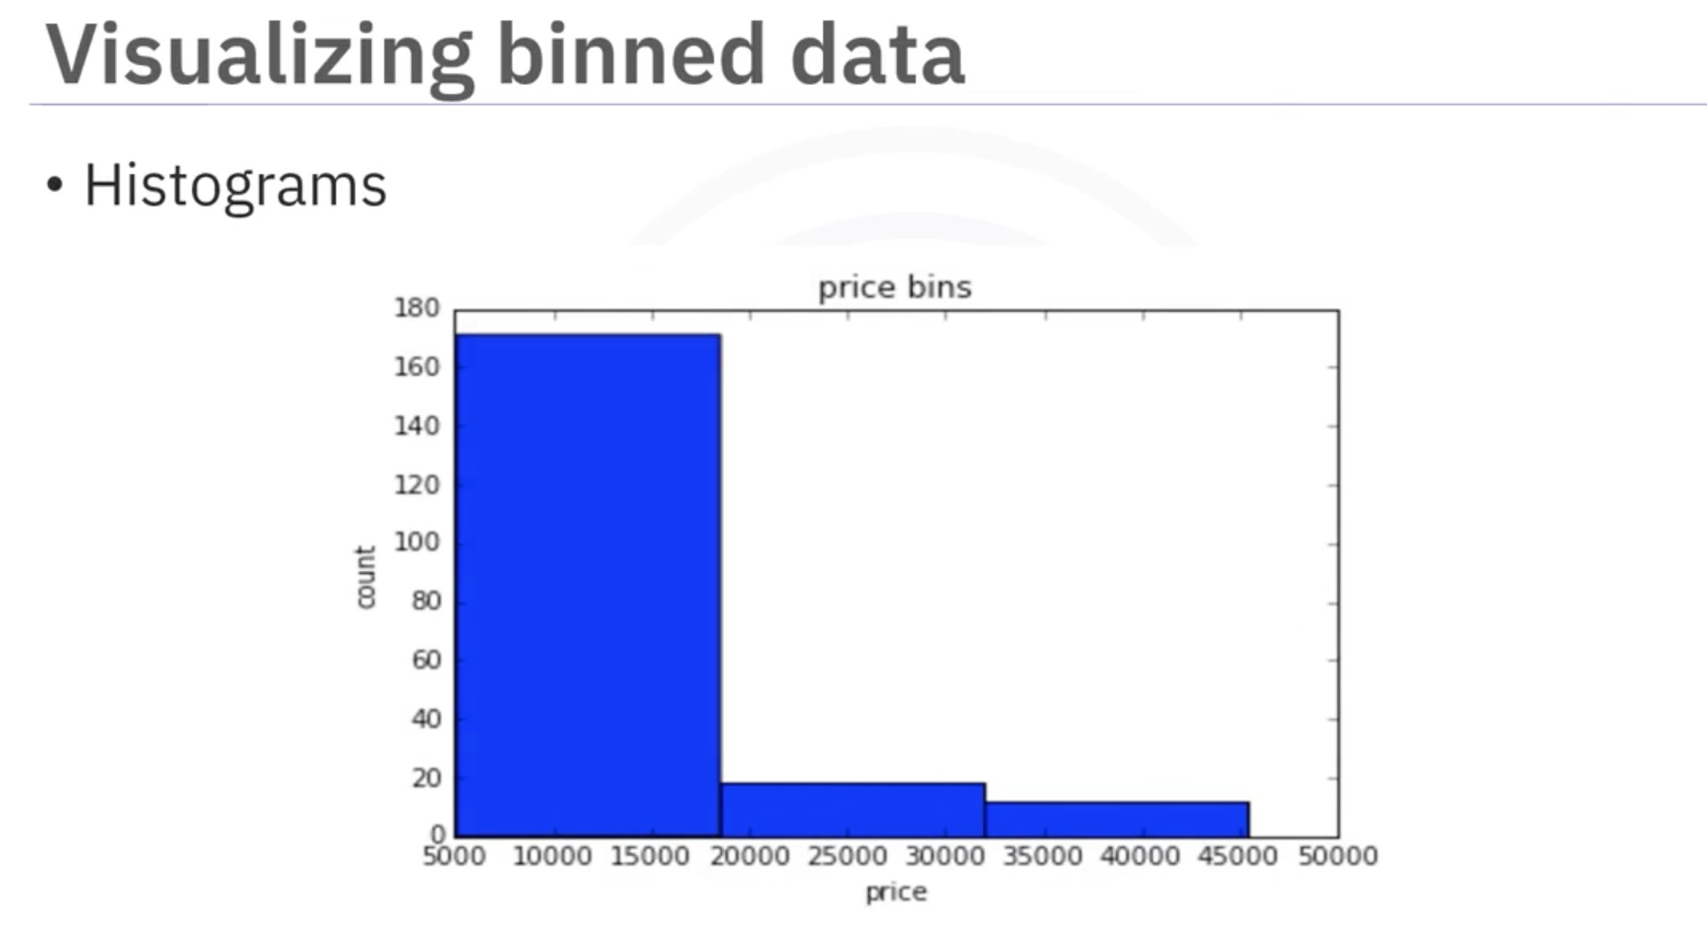

Summary
- Binning converts numerical data into categorical intervals.
- It simplifies analysis and visualization.
- In Python, NumPy and Pandas provide straightforward methods for implementing binning.
- Histograms help interpret the distribution after binning.

Converting Categorical Variables to Quantitative Variables

Introduction
Most statistical models cannot process objects or strings as inputs and require numerical values for model training. In Python, categorical variables must be converted into quantitative (numeric) variables before further analysis.

Example: Fuel Type in Car Dataset
Consider the fuel type feature in a car dataset, which has two string values: gas and diesel. For analysis, these categorical values need to be encoded into a numeric format.

One-Hot Encoding Technique
- Process:
  - Create new features corresponding to each unique value in the original categorical feature.
  - For each observation, assign 1 to the feature matching the category and 0 to all others.
- Example:
  - For Car B with fuel type diesel:
    - diesel = 1, gas = 0
  - For Car D with fuel type gas:
    - gas = 1, diesel = 0
This approach is called one-hot encoding.
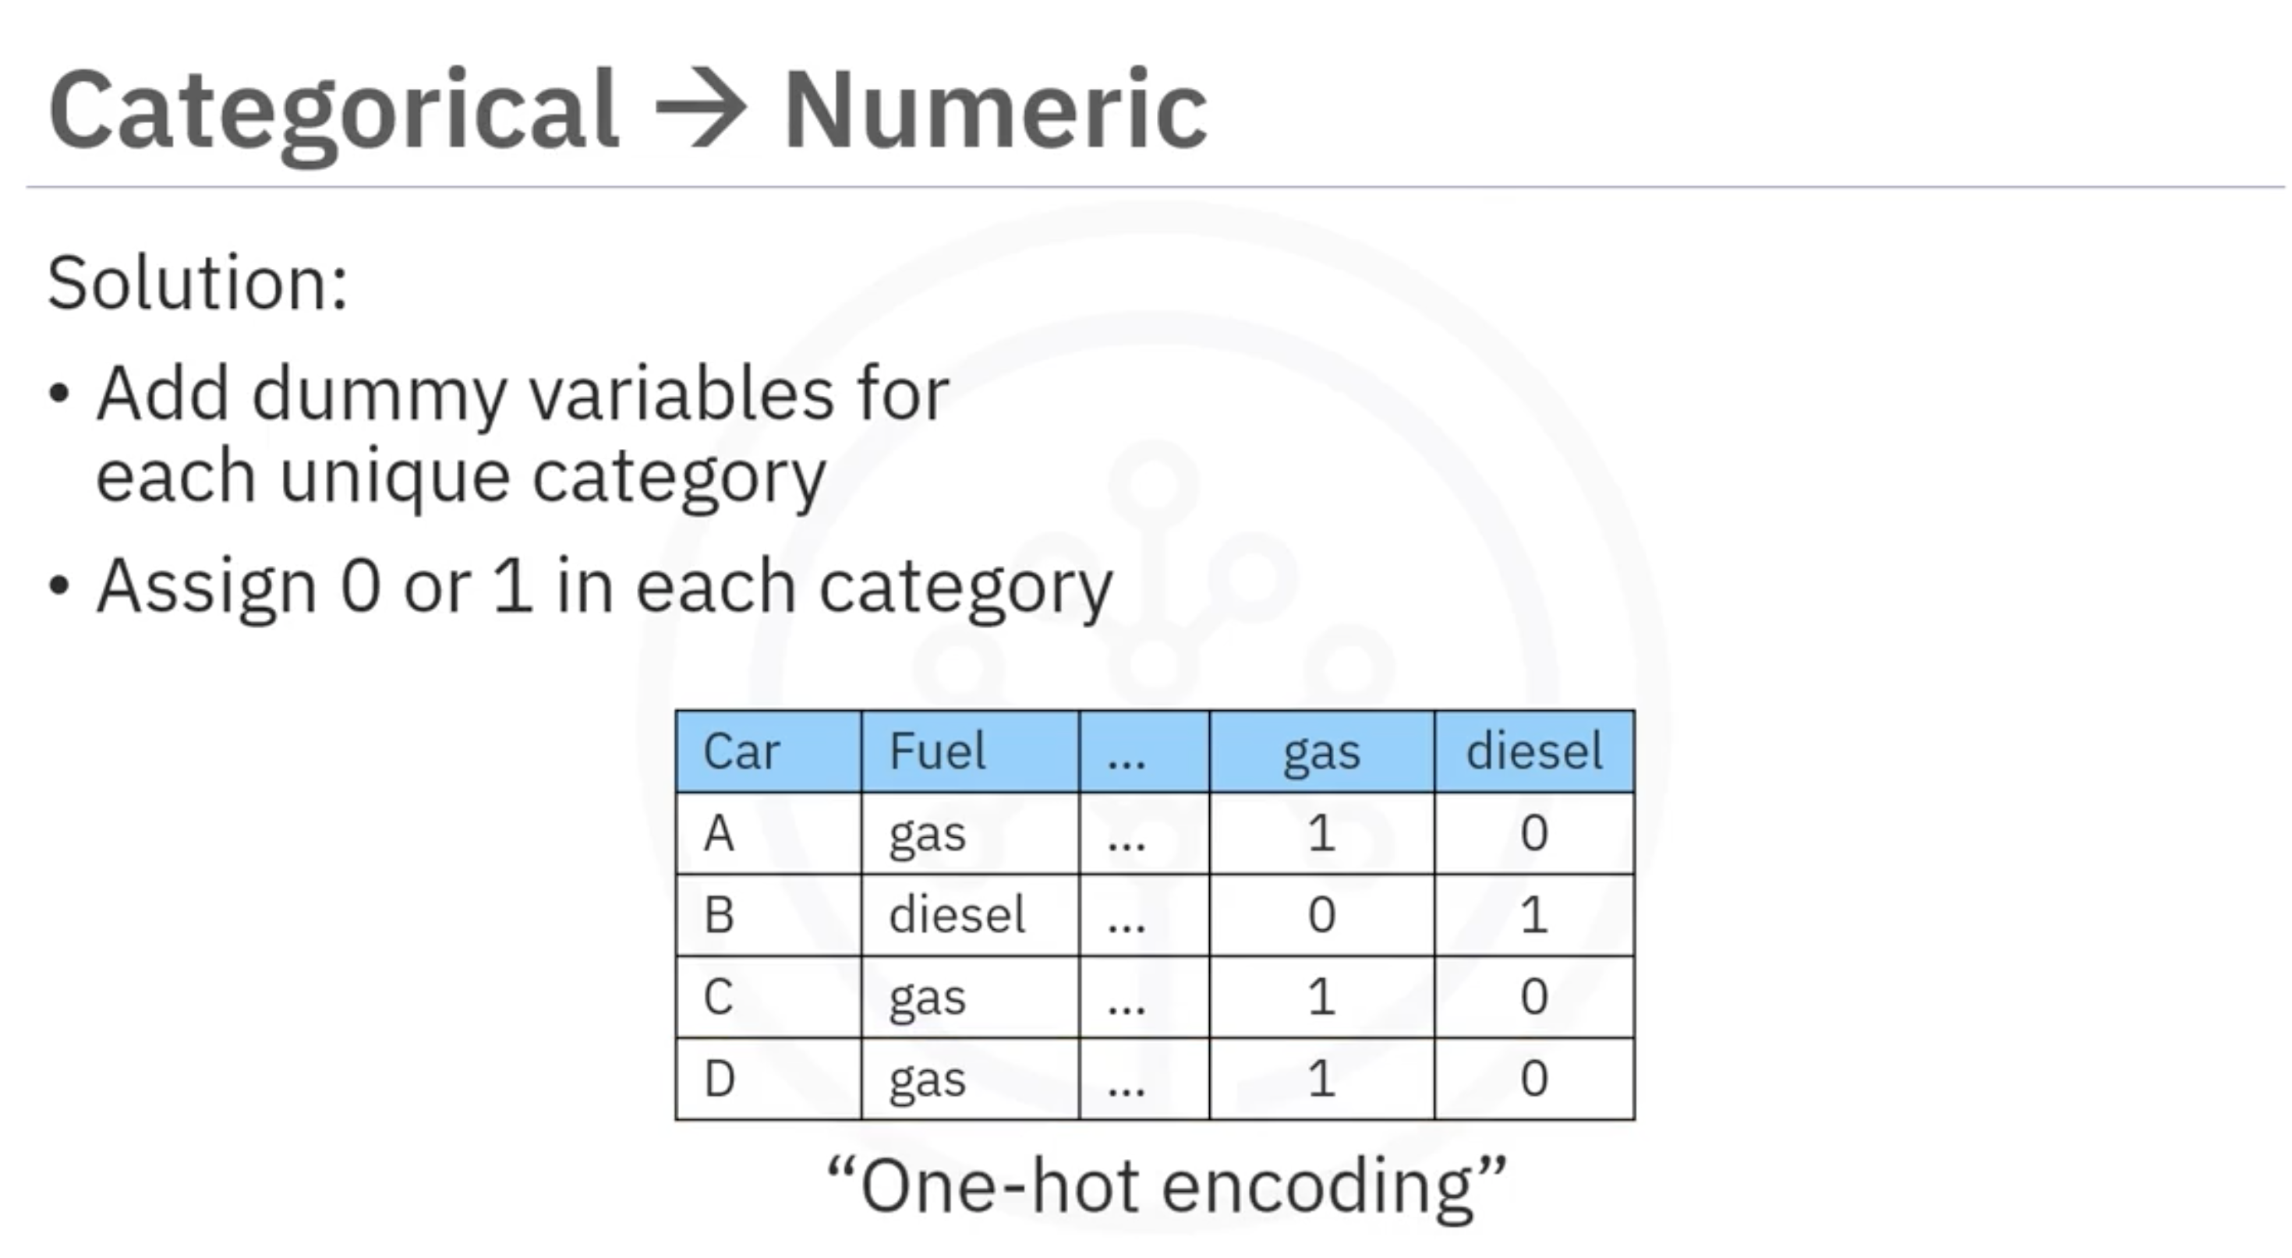

Implementing One-Hot Encoding in Python
- Using Pandas:
  - The get_dummies method in pandas can convert categorical variables into dummy variables automatically.
  - Example:
  - dummy_variable_one = pd.get_dummies(df['fuel'])
  - The method generates a new DataFrame with binary indicators for each category.

Summary
- Categorical variables must be encoded for statistical models.
- One-hot encoding creates binary variables for each category.
- Pandas' get_dummies simplifies this process efficiently.

Lesson Summary

Key Takeaways
At this point in the course, you know:

Data Formatting
- Data formatting is critical for making data from various sources consistent and comparable.
- You can master techniques in Python to convert units of measurement, such as transforming city miles per gallon to city-liters per 100 kilometers for easier comparison and analysis.

Data Types and Normalization
- Acquire skills to identify and correct data types in Python to ensure accurate representation for statistical analyses.
- Data normalization makes variables comparable and removes inherent biases in statistical models.
- Techniques include Feature Scaling, Min-Max, and Z-Score, all of which can be applied using pandas methods in Python.

Binning and Visualization
- Binning improves model accuracy and data visualization by categorizing numerical variables into intervals.
- You can run binning techniques in Python using numpy's linspace and pandas' cut methods.
- Use histograms to visualize the distribution of binned data and gain insights into feature distributions.

Encoding Categorical Variables
- Statistical models require numerical inputs, so categorical variables like fuel type must be converted into numeric formats.
- Implement one-hot encoding in Python using pandas’ get_dummies method to transform categorical variables for machine learning models.

Module 3

Outlier Detection

Definition
Outlier detection is the process of finding and possibly removing data points that are very different from the majority of the data.

Purpose
Outliers can distort statistical results and reduce model performance. Common examples include:
- Fraud detection
- Anomaly detection
- Data cleaning

Methods
- Z-Score Method
- IQR Method
- Isolation Forest
- DBSCAN
- Mahalanobis Distance

Interquartile Range (IQR)
The Interquartile Range (IQR) measures the spread of the central portion of the data:
- Q1 (25th percentile): 25% of the data lies below this value.
- Q3 (75th percentile): 75% of the data lies below this value.
- IQR: Q3 − Q1 → The range between Q1 and Q3.

Finding Outliers Using IQR
We assume points far away from the middle 50% are potential outliers.
- Lower Bound: Q1 − 1.5 × IQR
- Upper Bound: Q3 + 1.5 × IQR
Any data point:
- Less than the Lower Bound → Potential outlier (too small)
- Greater than the Upper Bound → Potential outlier (too large)

Example
Given the dataset:
Data: 5, 6, 7, 8, 10, 12, 15, 20, 50
- Q1 = 7
- Q3 = 15
- IQR = 15 − 7 = 8
Bounds:
- Lower Bound = 7 − 1.5(8) = −5
- Upper Bound = 15 + 1.5(8) = 27
Conclusion:
Values outside the range −5 to 27 are outliers. Here, 50 is an outlier.

Introduction to Exploratory Data Analysis (EDA)
In this module, we are going to cover the basics of exploratory data analysis (EDA) using Python.
Exploratory Data Analysis (EDA) is an approach to analyze data in order to:
- Summarize the main characteristics of the dataset.
- Gain a better understanding of the data.
- Uncover relationships between different variables.
- Identify important variables that influence the problem we are trying to solve.
The main question we aim to answer in this module is:
What are the characteristics that have the most impact on the car price?
To address this question, we will explore several useful EDA techniques.

Key Learning Areas
In this module, we will learn about the following key areas:

Descriptive Statistics
Descriptive statistics describe the basic features of a dataset and provide a summary of the sample and its measures. They help in understanding the central tendency, dispersion, and distribution of the data.

Grouping Data using GroupBy
We will learn how to group data using the GroupBy function and how it helps to transform and summarize datasets effectively.

ANOVA (Analysis of Variance)
ANOVA is a statistical method used to analyze the differences among group means in a dataset by dividing the variation into distinct components.

Correlation Analysis
We will examine the correlation between various variables to understand how they interact with one another.

Advanced Correlation Techniques
In this section, we will introduce advanced correlation methods, including:
- Pearson Correlation — measures linear relationships between variables.
- Correlation Heatmaps — visualize the strength and direction of relationships across multiple variables.

Descriptive Statistics
When beginning data analysis, it is essential to first explore the dataset before building complex models. One effective approach to examine and summarize data is through descriptive statistics.
Descriptive statistical analysis helps to describe the basic features of a dataset and provides a concise summary of the sample and its measures.

Using the describe() Function in Pandas
One easy way to generate descriptive statistics is by using the describe() function in the Pandas library.

Purpose
The describe() function automatically computes basic statistics for all numerical variables, including:
- Mean
- Total number of data points
- Standard deviation
- Quartiles (25%, 50%, 75%)
- Minimum and maximum values
Note: Any NaN (missing) values are automatically ignored in these calculations.
This function provides a clear overview of the distribution and variability of your dataset’s numerical variables.

Working with Categorical Variables
Datasets often include categorical variables, which represent discrete groups or categories. For example, the drive system variable in a car dataset can include the following categories:
- Front wheel-drive
- Rear wheel-drive
- Four wheel-drive

Summarizing Categorical Data
A simple way to summarize categorical data is by using the value_counts() function.
Example:
- 118 cars belong to the front-wheel-drive category.
- 75 cars belong to the rear-wheel-drive category.
- 8 cars belong to the four-wheel-drive category.
You can also rename the column for better readability when presenting the results.

Visualizing Data with Box Plots
Box plots are an excellent way to visualize the distribution of numerical data.

Key Features of a Box Plot
- Median: The midpoint of the data.
- Upper Quartile (Q3): Represents the 75th percentile.
- Lower Quartile (Q1): Represents the 25th percentile.
- Interquartile Range (IQR): The range between Q1 and Q3.
- Extremes: Calculated as 1.5 × IQR above Q3 and below Q1.
- Outliers: Data points outside the upper and lower extremes, shown as individual dots.
Box plots help identify outliers, distribution shape, and skewness in the data. They are particularly useful for comparing distributions across different groups.
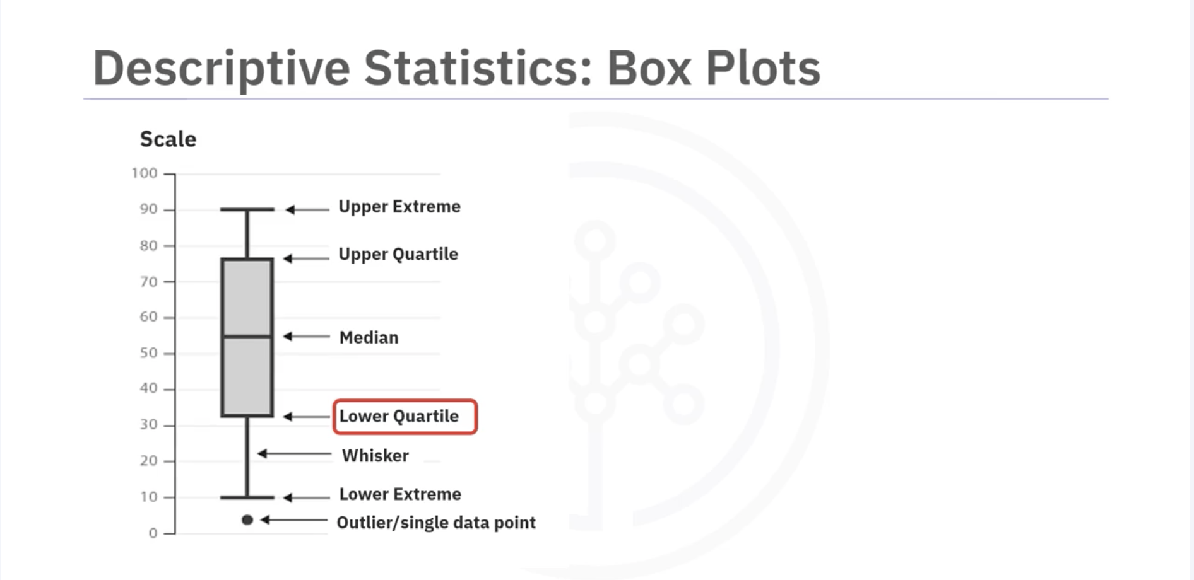

Example
Using box plots, we can visualize the distribution of car prices across different drive-wheel categories. The box plot reveals that:
- Prices for rear-wheel-drive cars differ significantly from other categories.
- Prices for front-wheel-drive and four-wheel-drive cars are almost indistinguishable.
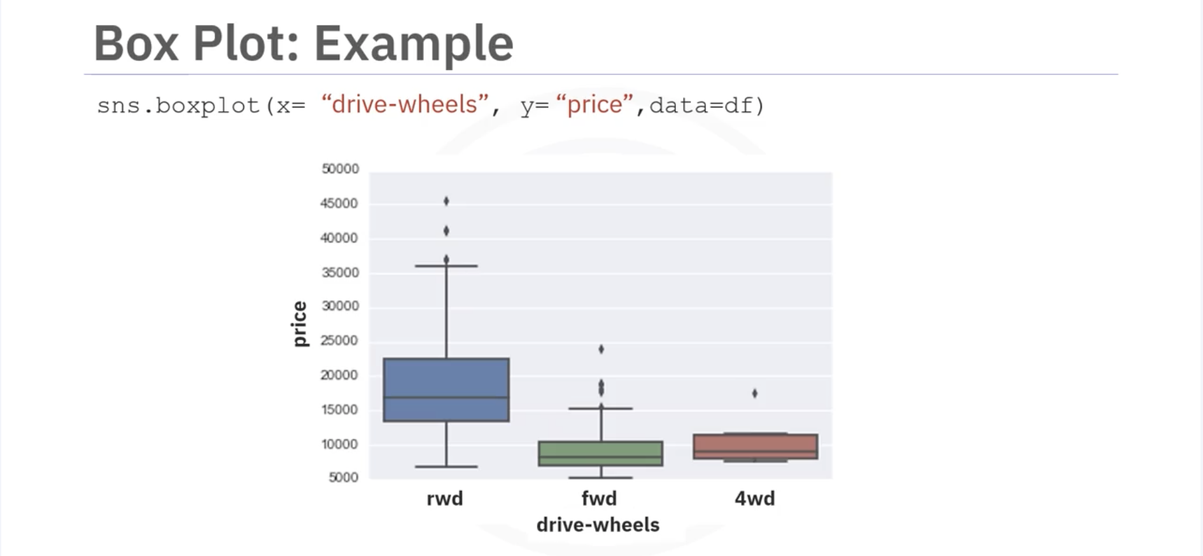

Analyzing Continuous Variables with Scatter Plots
Many datasets contain continuous variables—numerical values that exist within a specific range. For instance, in a car dataset:
- Price and engine size are continuous variables.

Exploring Relationships with Scatter Plots
A scatter plot is useful for visualizing the relationship between two continuous variables.
Each observation in the dataset is represented as a single point on the plot.
- Predictor Variable (X-axis): The variable used to predict an outcome (e.g., engine size).
- Target Variable (Y-axis): The variable being predicted (e.g., price).
In this case, we plot engine size on the x-axis and price on the y-axis using the Matplotlib function scatter().

Best Practices for Scatter Plots
- Always label axes clearly.
- Add a descriptive title to explain what the plot represents.

Insights from the Scatter Plot
From the scatter plot, we can observe that as engine size increases, the price of the car also tends to increase. This suggests a positive linear relationship between the two variables.

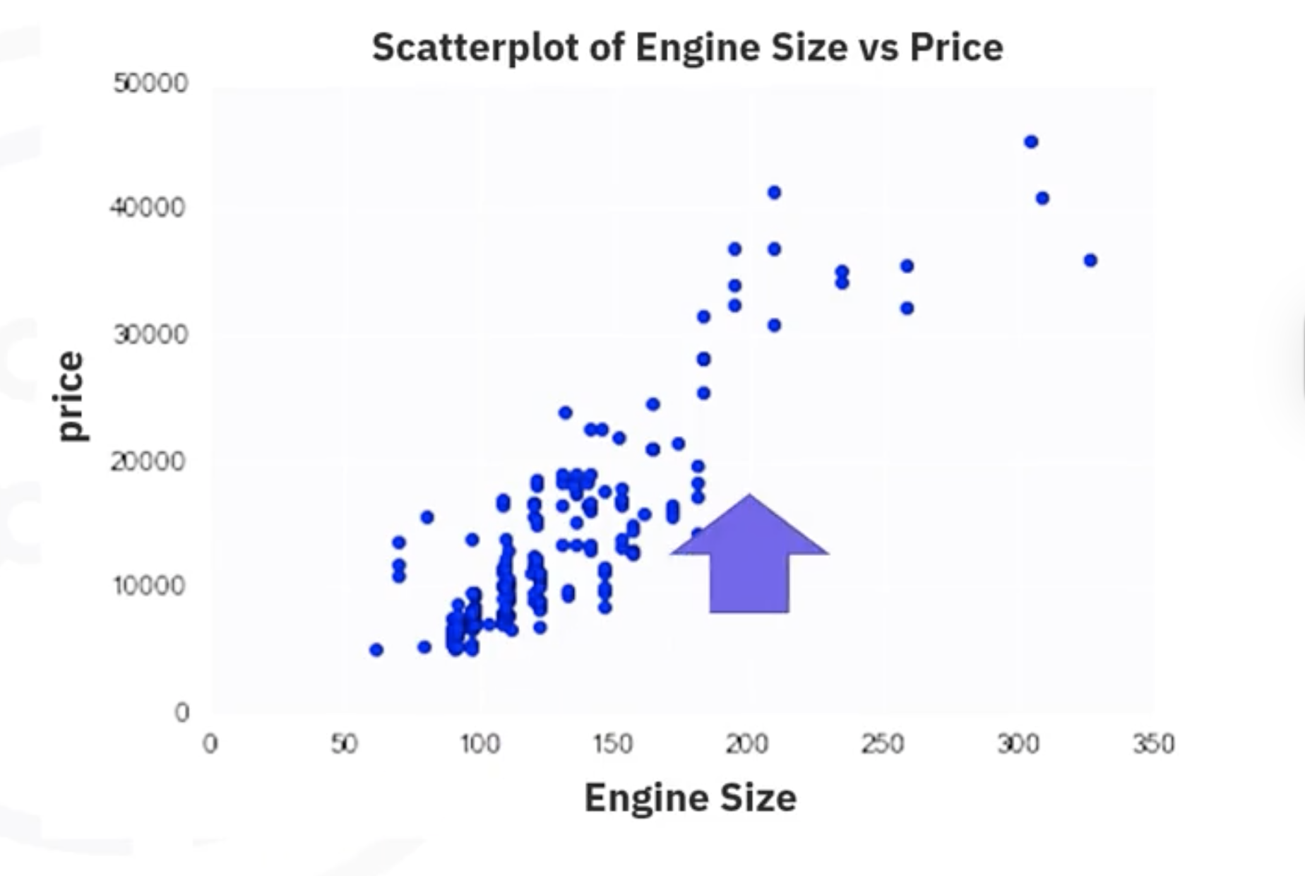

Grouping and Transforming Data in Pandas
Grouping data allows us to analyze relationships between different categories and numerical values within a dataset. In this section, we explore how to group data in Pandas and transform it into more meaningful visual formats.

Understanding the GroupBy Method
The groupby() method in Pandas is a powerful function used to group data based on categorical variables. It divides the dataset into subsets according to the categories of a selected variable or multiple variables.

Purpose of Grouping
Grouping helps to:
- Identify relationships between categories.
- Compare statistical summaries (e.g., mean, median) across categories.
- Simplify complex datasets for better analysis.
For example, suppose we want to explore whether there is a relationship between drive system type (front-wheel, rear-wheel, four-wheel drive) and vehicle price. We can use the groupby() method to compare average prices across these categories.

Grouping by Multiple Variables
We can group data by one or more categorical variables. For instance, if we are interested in the average price of vehicles by both drive wheels and body style, we can perform the following steps:
- Select Relevant Columns: Extract only the necessary data columns such as drive-wheels, body-style, and price.
- Apply Grouping: Use the groupby() function to group the data by drive-wheels and body-style.
- Compute Mean Values: Use the mean() function to find the average price within each group.
The resulting grouped data shows how average prices vary across combinations of drive wheels and body styles. For example, according to the data:
- Rear-wheel drive convertibles and rear-wheel drive hardtops have the highest average prices.
- Four-wheel drive hatchbacks have the lowest average prices.

Using Pivot Tables for Easier Visualization
A pivot table provides a clearer, more structured way to view grouped data. In Pandas, you can create a pivot table using the pivot() method.

Concept of Pivot Tables
A pivot table reorganizes data so that:
- One variable is displayed along the rows.
- Another variable is displayed along the columns.
This layout creates a rectangular grid of data that is easier to interpret—similar to how data is represented in Excel spreadsheets.

Example in Pandas
Using one line of code with the pivot() method, we can pivot the body-style variable to appear as columns and the drive-wheels variable as rows. The resulting grid shows average prices for each combination of these variables.

Visualizing Pivot Tables with Heat Maps
A heat map is an excellent tool for visualizing pivot table data. It assigns color intensities based on numerical values, providing visual cues about data patterns.

Creating a Heat Map
In this example, we use the pcolor() function from Matplotlib’s Pyplot module to create a heat map of average vehicle prices.
- The x-axis represents body styles.
- The y-axis represents drive wheels.
- Color intensity represents the average price, according to the color bar.

Insights from the Heat Map
The heat map provides a quick and intuitive view of how vehicle prices vary across drive-wheel and body-style combinations:
- The upper section (e.g., rear-wheel drive convertibles) shows higher prices.
- The lower section (e.g., four-wheel drive hatchbacks) shows lower prices.
This visual representation helps to quickly identify which categories add the most value to vehicles.
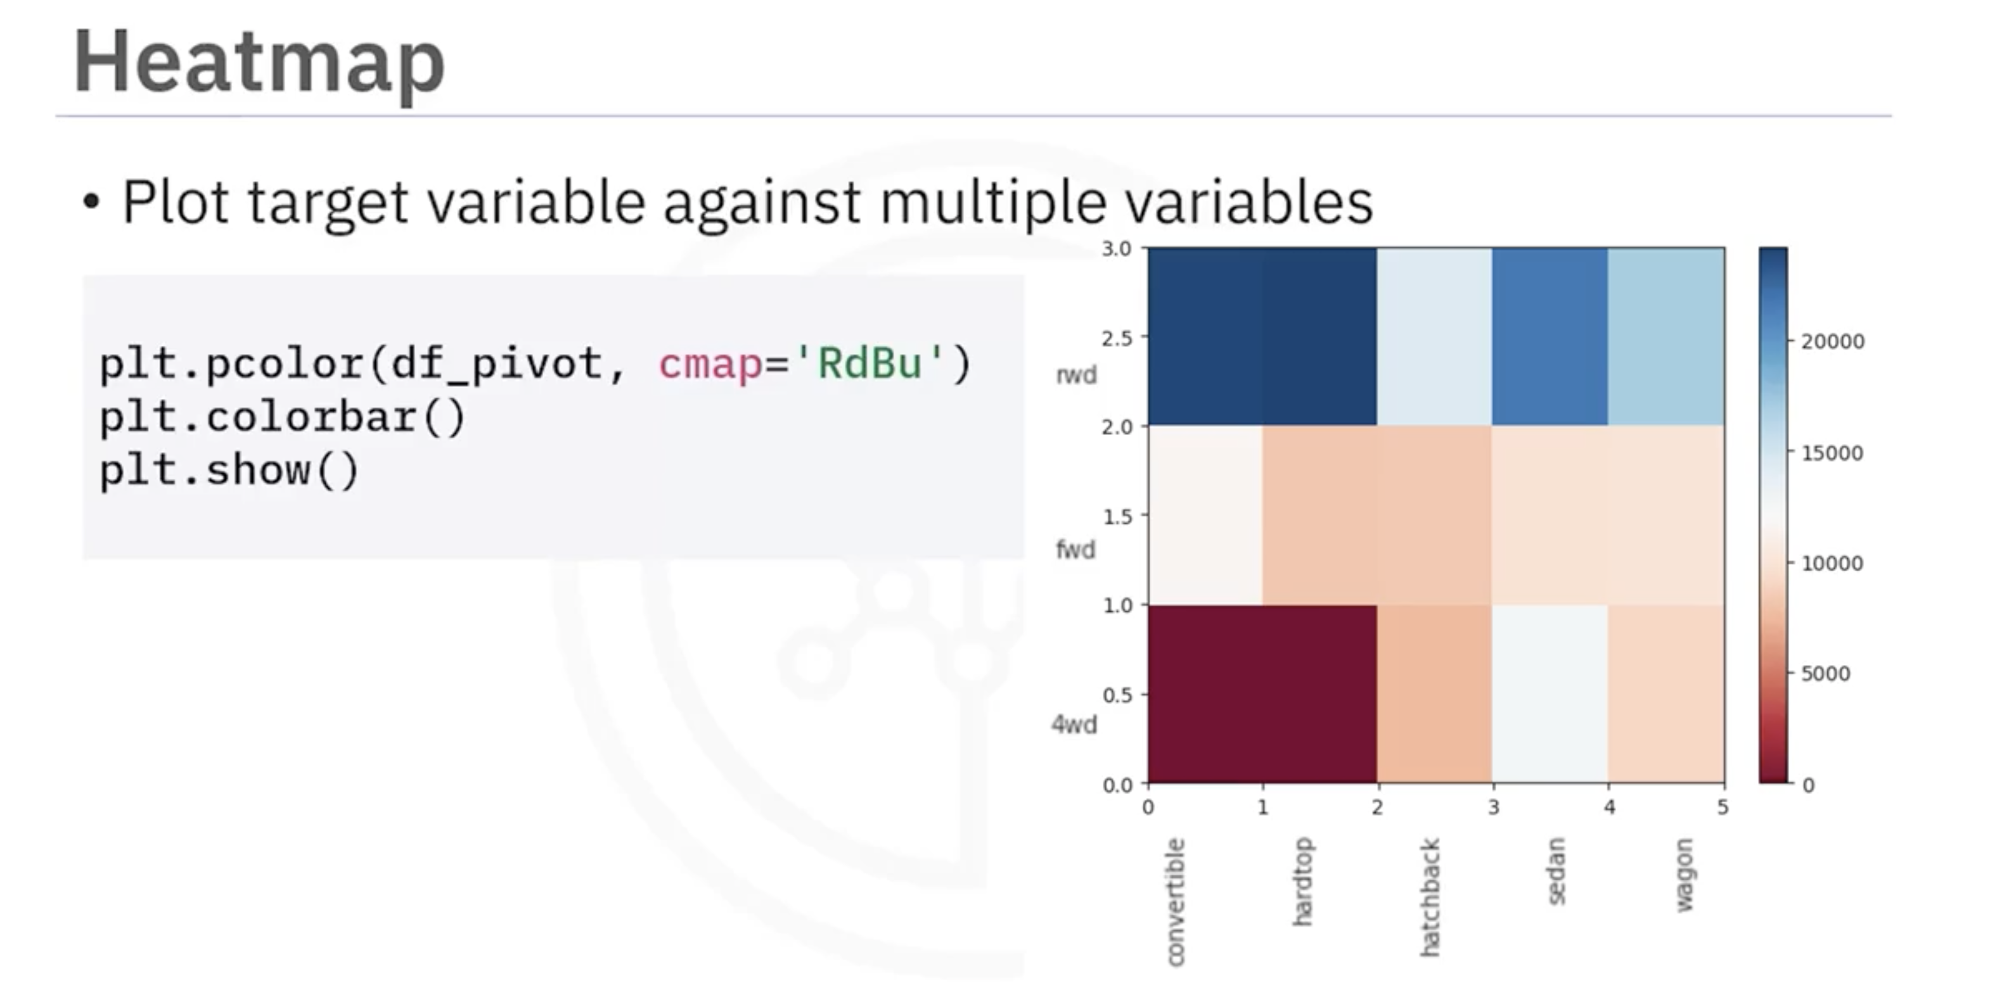

Data Visualization Commands in Python
Visualizations play a key role in data analysis. In this section, we explore various types of graphs and plots that can be created in Python to better understand and analyze data. The two major libraries used for data visualization are Matplotlib and Seaborn.

Importing Libraries
To begin visualizing data, we first need to import the necessary libraries.

Importing Matplotlib
from matplotlib import pyplot as plt
Alternatively:
import matplotlib.pyplot as plt
Most plotting functions of interest are found in the pyplot submodule. When working in Jupyter Notebooks, it’s recommended to use the following magic command to ensure plots display inline:
%matplotlib inline

Importing Seaborn
Seaborn is typically imported using the following command:
import seaborn as sns

Matplotlib Functions

Standard Line Plot
A line plot is the simplest and most fundamental type of visualization. It represents data points connected by straight lines.
Syntax:
plt.plot(x, y)
Here, x and y are arrays of equal length representing independent and dependent variables, respectively.
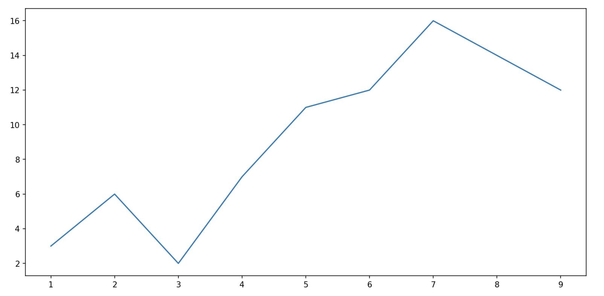

Scatter Plot
A scatter plot displays the relationship between two numerical variables using points on a two-dimensional plane.
Syntax:
plt.scatter(x, y)
You can modify marker size, color, and shape using additional arguments.
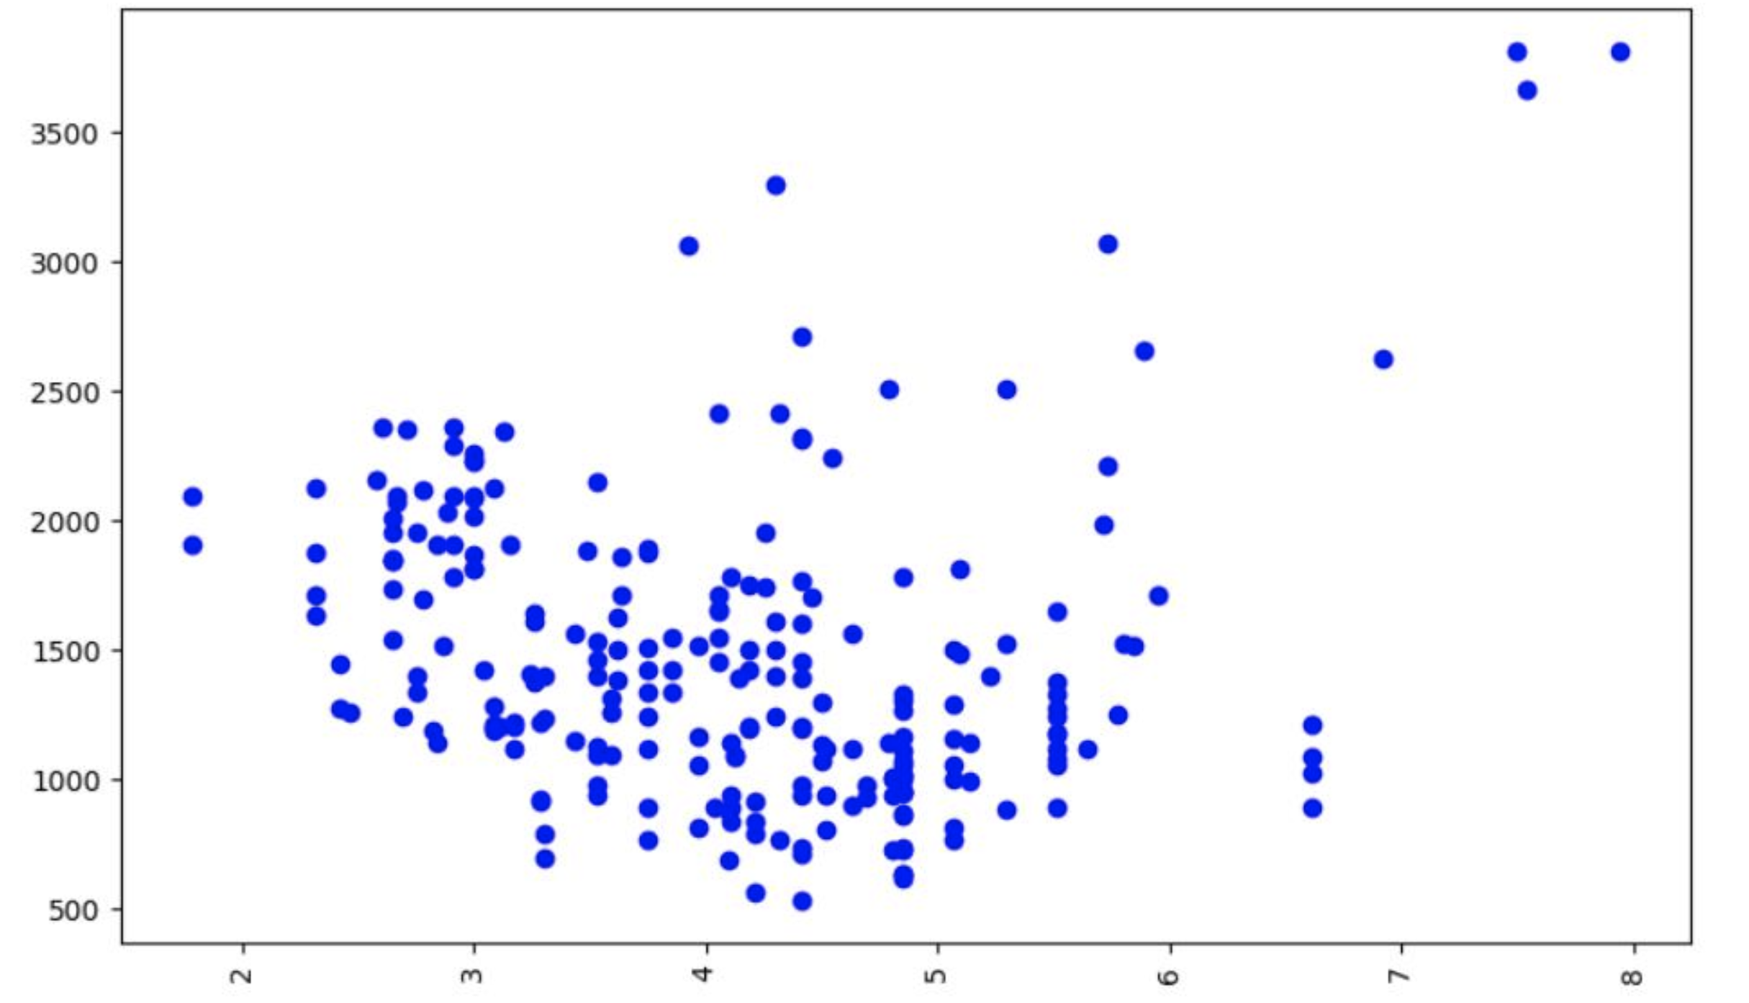

Histogram
A histogram represents data distribution using bins. The x-axis shows data intervals (bins), while the y-axis shows frequency counts.
Syntax:
plt.hist(x, bins)
You can enhance clarity by adding an edge color:
plt.hist(x, bins, edgecolor='black')
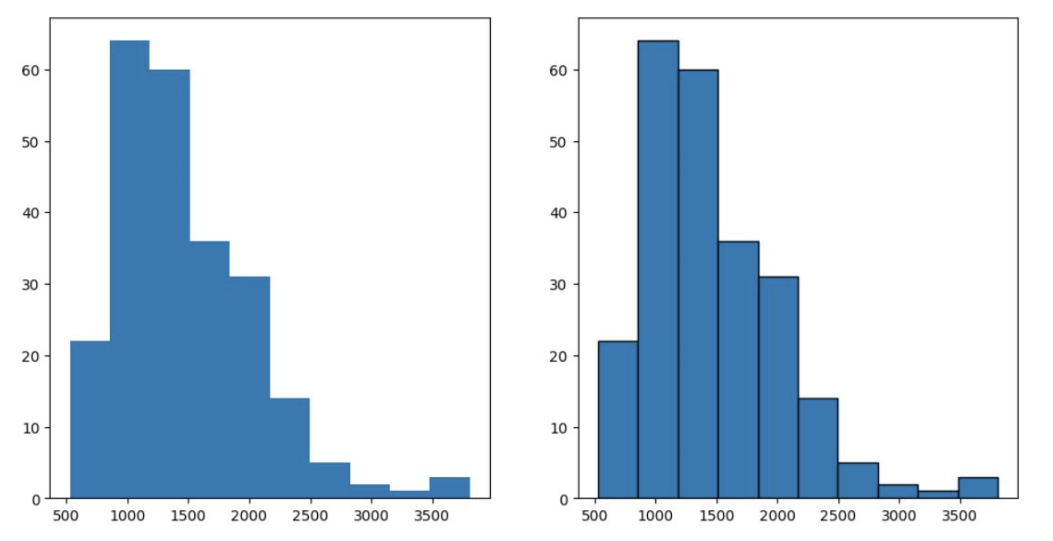

Bar Plot
A bar plot visualizes categorical data, where each bar represents a category’s value.
Syntax:
plt.bar(x, height)
Here, x represents categories and height represents their corresponding values.
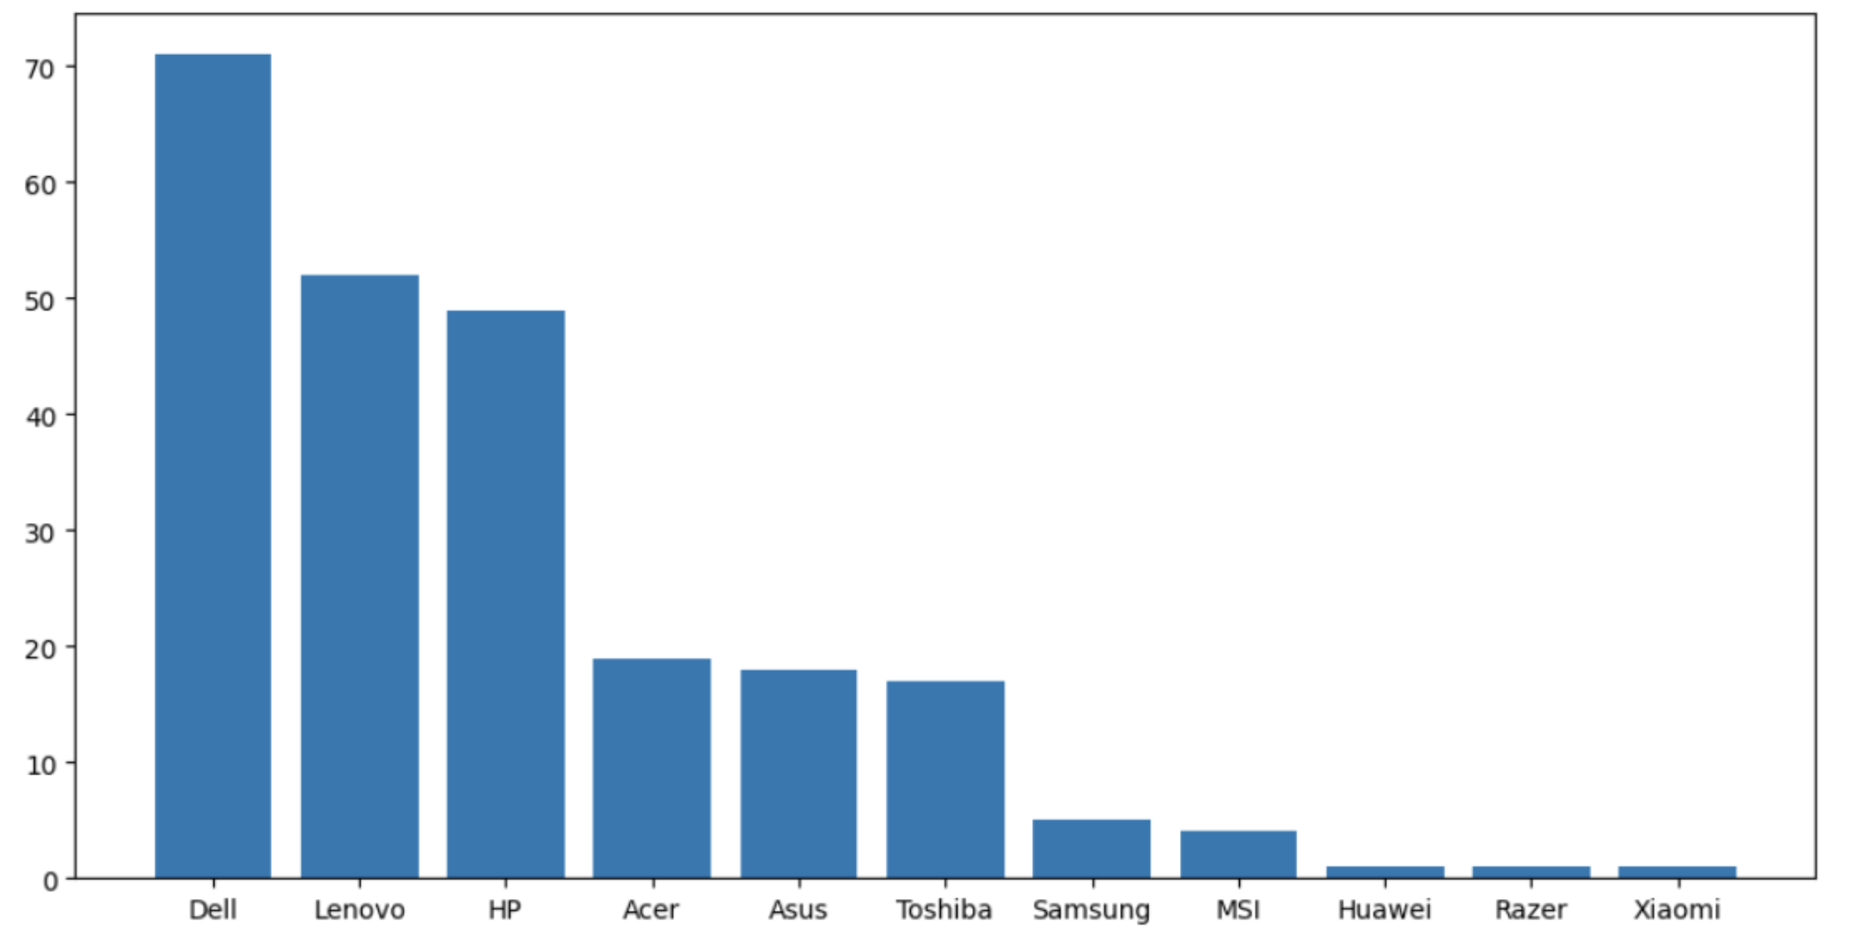

Pseudo Color Plot
A pcolor plot displays matrix data as colored cells, ideal for visualizing pivot tables.
Syntax:
plt.pcolor(C, cmap='viridis')
Where C is a matrix and cmap defines the color scheme.
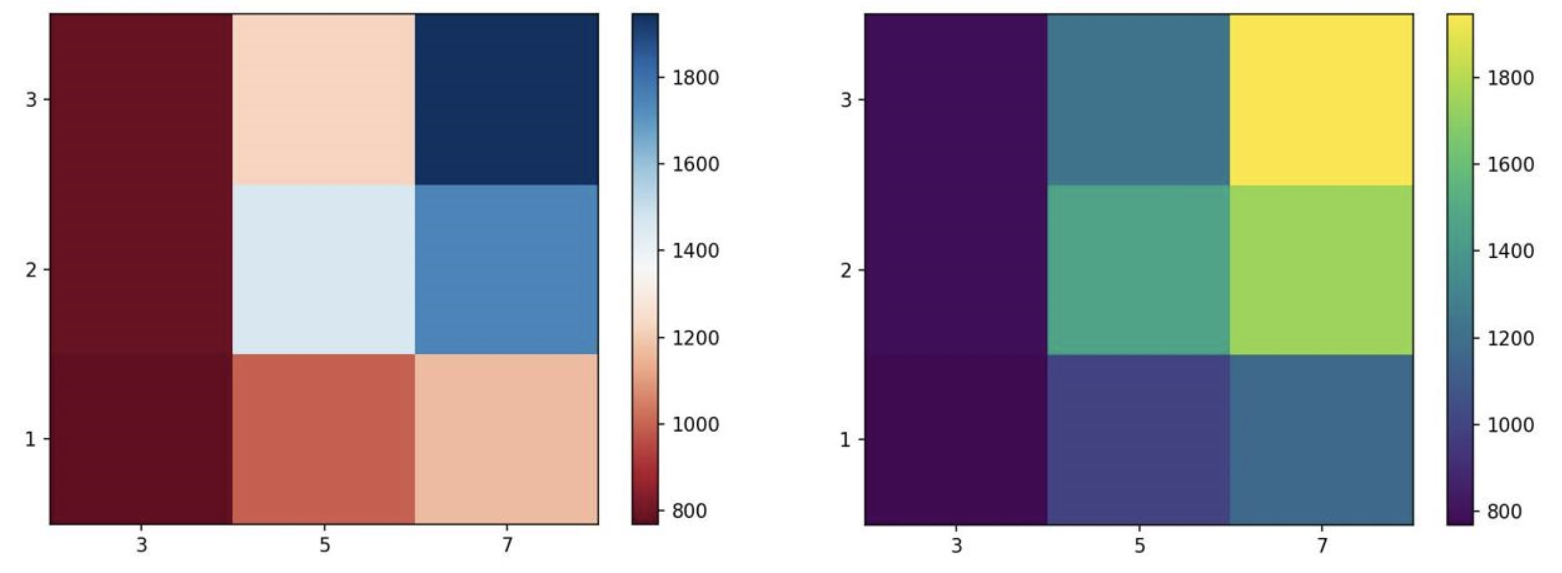

Seaborn Functions

Regression Plot
A regression plot draws a scatter plot along with a fitted regression line and confidence interval.
Syntax:
sns.regplot(x='header_1', y='header_2', data=df)
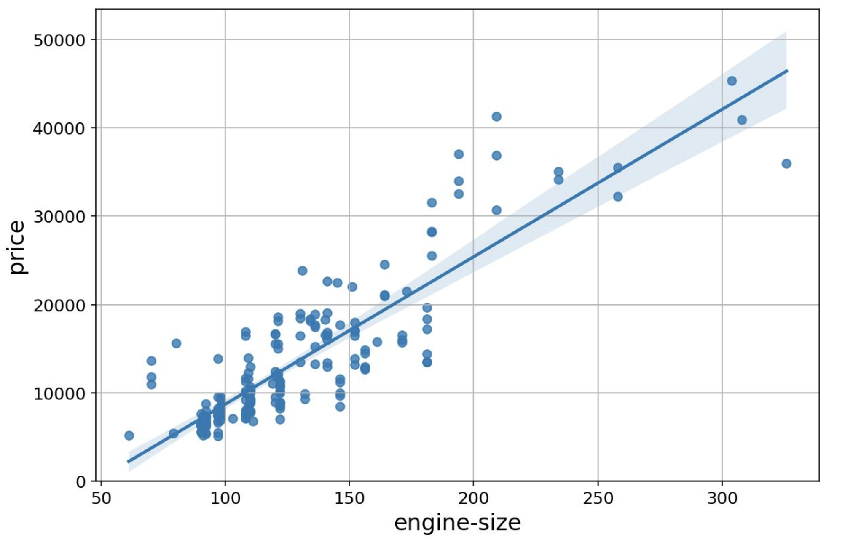

Box and Whisker Plot
A box plot visualizes the distribution of numerical data, showing quartiles and outliers.
Syntax:
sns.boxplot(x='category', y='value', data=df)
The box represents the interquartile range (IQR), and whiskers extend to show the rest of the distribution.
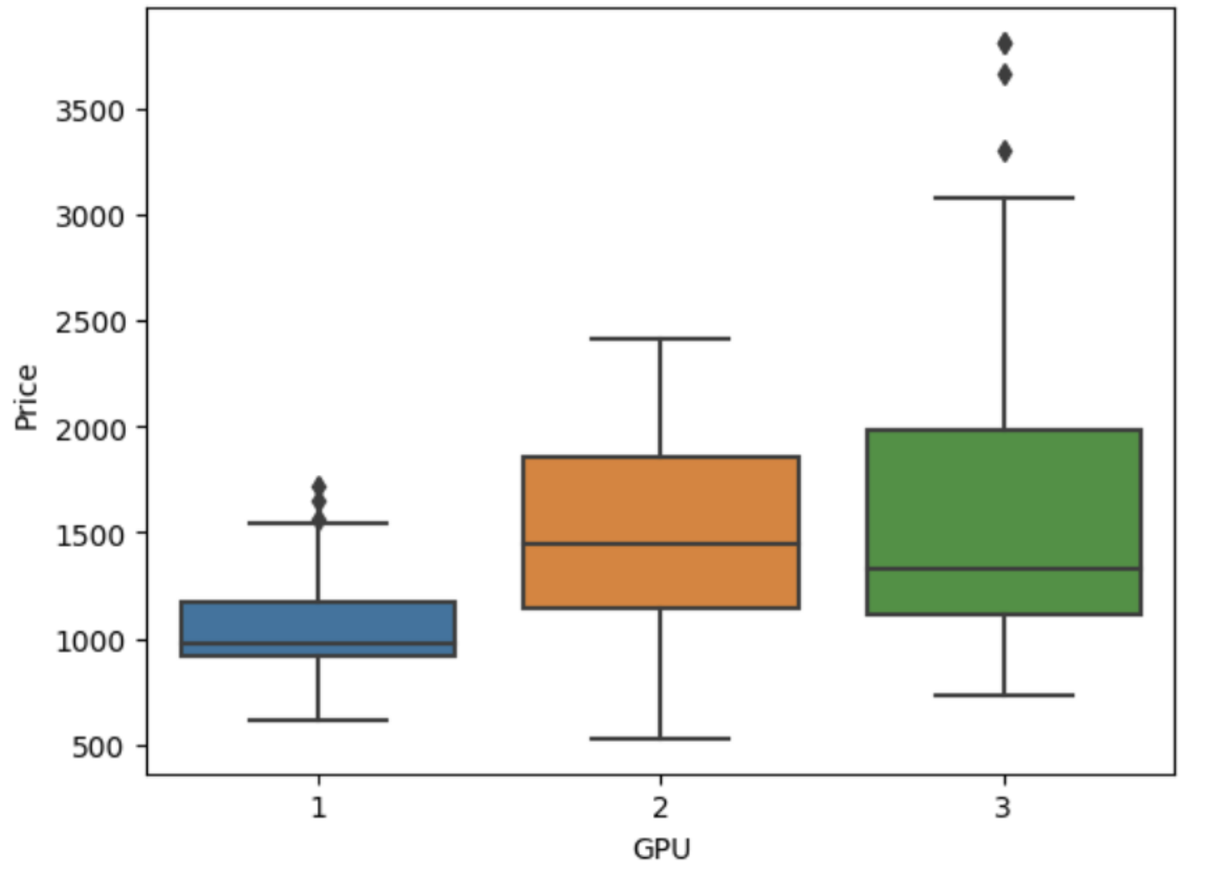

Residual Plot
A residual plot is used to evaluate regression model performance by showing the difference between observed and predicted values.
Syntax:
sns.residplot(x='header_1', y='header_2', data=df)
Alternatively:
sns.residplot(x=df['header_1'], y=df['header_2'])

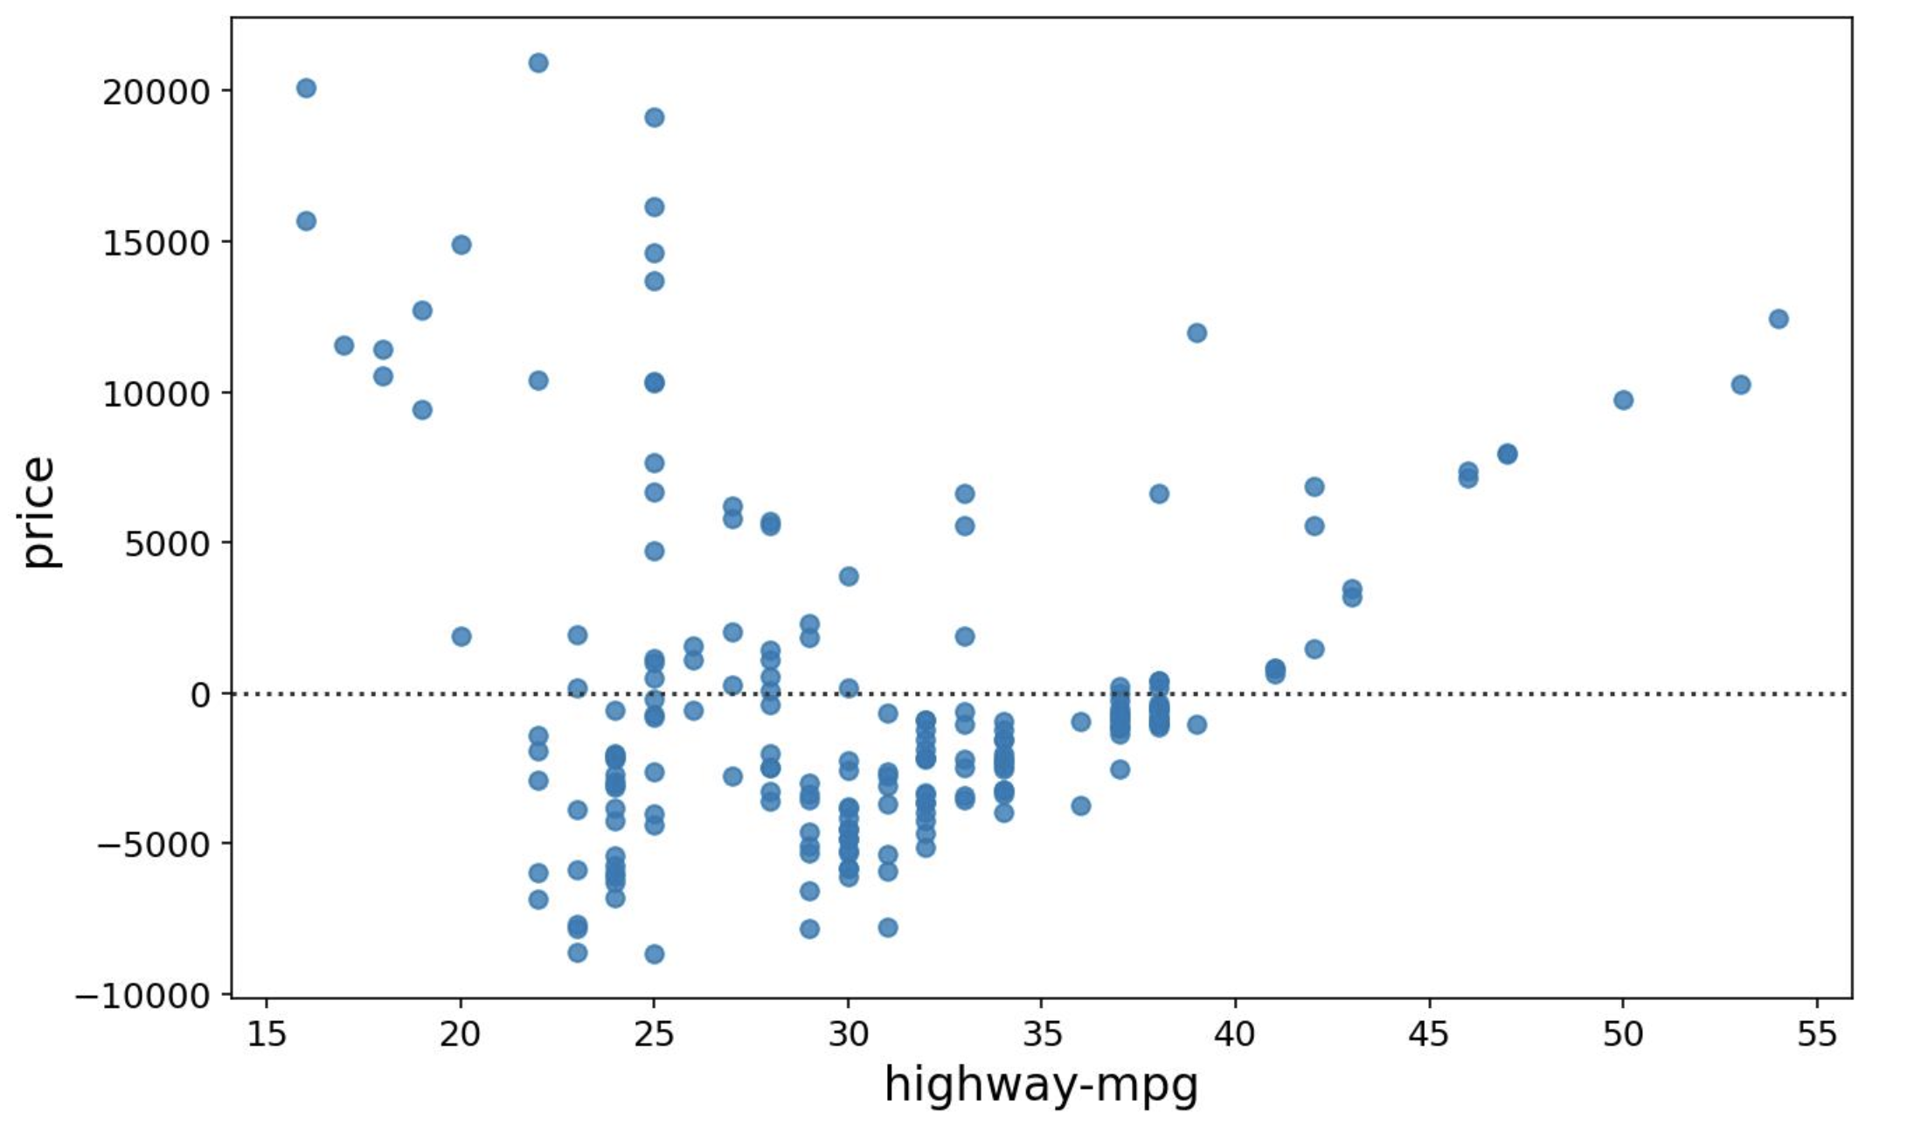

KDE Plot
A Kernel Density Estimate (KDE) plot visualizes the probability distribution of a dataset.
Syntax:
sns.kdeplot(X)
This plot shows the likelihood of data occurrences along the value range.
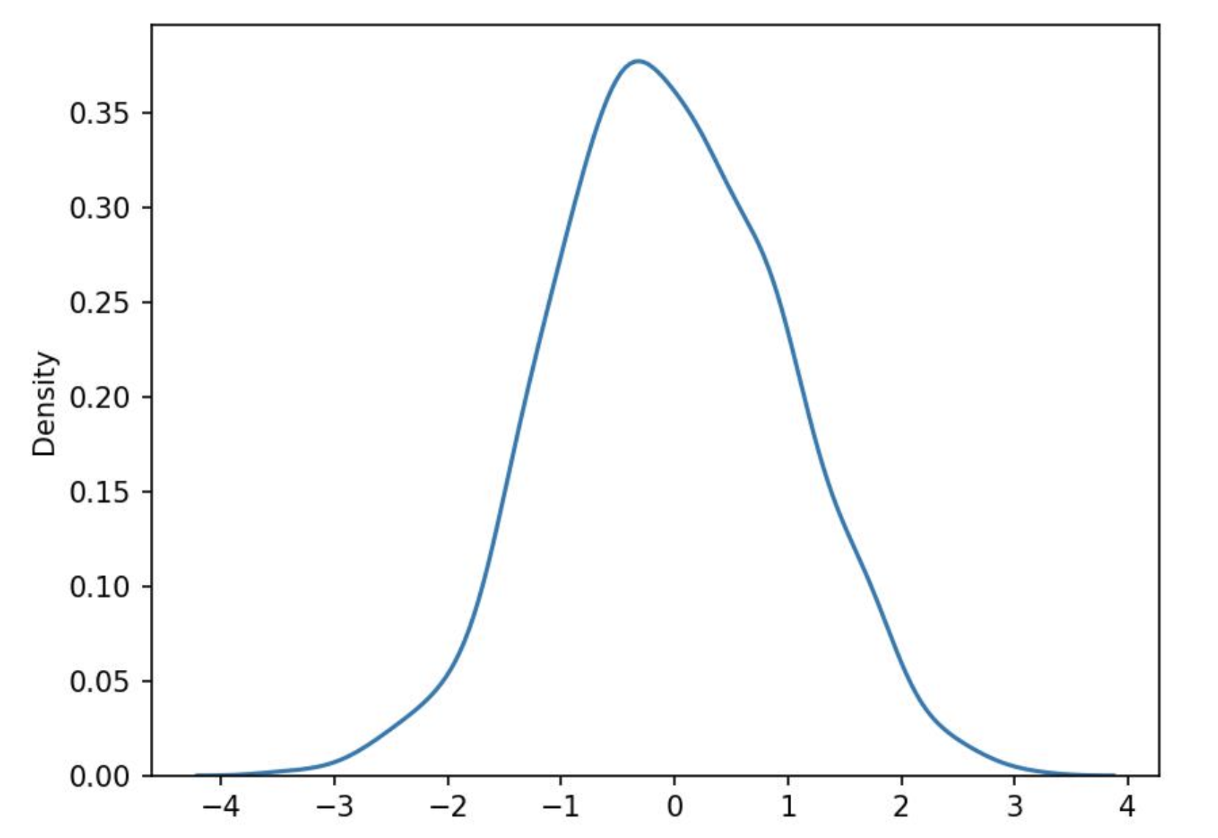

Distribution Plot
A distribution plot combines a histogram and a KDE plot, allowing comparison of both in a single visualization.
Syntax:
sns.distplot(X, hist=False)
Setting hist=True includes both the histogram and the KDE curve.
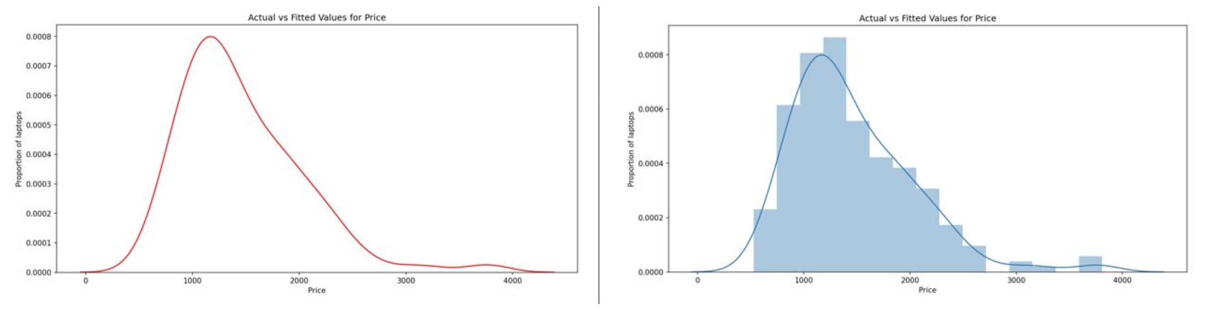

Conclusion
This section summarizes key visualization techniques in Python using Matplotlib and Seaborn. These plots—ranging from simple line and scatter plots to complex regression and KDE plots—enable better insights into data patterns and relationships.

Correlation Between Variables

Understanding Correlation
Correlation is a statistical metric that measures the degree to which two variables are interdependent. In other words, it shows how the change in one variable affects the change in another variable over time.

Examples of Correlation
- Smoking and Lung Cancer: There is a positive correlation because individuals who smoke have a higher chance of developing lung cancer.
- Umbrella and Rain: When precipitation increases, more people carry umbrellas. If it doesn’t rain, fewer people use umbrellas. Therefore, these two variables are interdependent and correlated.

Correlation vs. Causation
It is important to remember that correlation does not imply causation. Although umbrellas and rain are correlated, we cannot conclude that umbrellas cause rain or vice versa. In data science, we usually focus on understanding correlation rather than establishing causation.

Visualizing Correlation
To understand relationships between variables, we can visualize them using scatter plots and regression lines.

Example 1: Engine Size vs. Price
When comparing engine size and car price:
- A scatter plot with a regression line shows a positive linear relationship.
- As engine size increases, the car price also increases.
- The steep positive slope of the line indicates a strong positive correlation.
You can use Seaborn’s regplot() function to create this type of plot:
sns.regplot(x='engine-size', y='price', data=df)

Example 2: Highway Miles per Gallon vs. Price
When comparing highway miles per gallon (mpg) and car price:
- The scatter plot shows a negative linear relationship.
- As highway mpg increases, car price decreases.
- Despite being negative, the steep slope means highway mpg is still a good predictor of price.
sns.regplot(x='highway-mpg', y='price', data=df)

Example 3: Peak RPM vs. Price
In this case, both low and high RPM values correspond to low and high prices, showing no clear pattern. Therefore, RPM is weakly correlated with price and is not a reliable predictor.

Summary
- Correlation measures the interdependence between variables.
- Correlation does not imply causation.
- Visualizations like scatter plots and regression lines help identify the type and strength of correlation.
- Relationships can be positive, negative, or weak depending on how one variable affects another.

Correlation Between Variables

Introduction to Correlation Methods
In this section, we examine various statistical methods for measuring the strength and direction of relationships between continuous numerical variables. One of the most common and powerful methods is the Pearson Correlation.

Pearson Correlation
The Pearson Correlation method measures the linear relationship between two continuous variables. It provides two key outputs:
- Correlation Coefficient (r)
- p-value

Interpreting the Correlation Coefficient
- A value close to 1 indicates a strong positive correlation.
- A value close to -1 indicates a strong negative correlation.
- A value close to 0 indicates no correlation between the variables.

Interpreting the p-value
The p-value indicates the level of confidence we have in the correlation coefficient.
- p < 0.001 → Strong certainty about the correlation.
- 0.001 ≤ p < 0.05 → Moderate certainty.
- 0.05 ≤ p < 0.1 → Weak certainty.
- p ≥ 0.1 → No certainty of correlation.

Strong Correlation Example
A strong correlation occurs when the correlation coefficient is close to 1 or -1 and the p-value < 0.001.
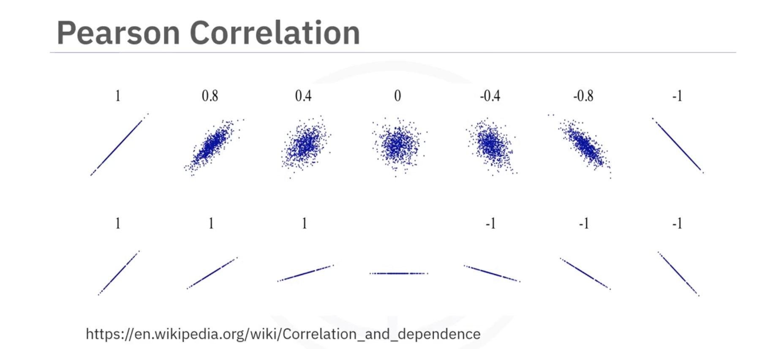
For example, when analyzing the relationship between horsepower and car price:
- The correlation coefficient is approximately 0.8, indicating a strong positive correlation.
- The p-value is much smaller than 0.001, meaning we are highly certain about this relationship.
You can calculate the Pearson Correlation easily using the SciPy stats package:
from scipy import stats
stats.pearsonr(df['horsepower'], df['price'])

Correlation Heat Map
To visualize multiple correlations between several variables, we can create a correlation heat map.

Understanding the Heat Map
- The color scheme represents the Pearson correlation coefficient between pairs of variables.
- A dark red diagonal line shows where each variable is correlated with itself (always equal to 1).
- This provides a clear visual overview of how all variables relate to one another, especially how they relate to price.
import seaborn as sns
import matplotlib.pyplot as plt

plt.figure(figsize=(10, 8))
sns.heatmap(df.corr(), annot=True, cmap='RdBu_r')
plt.show()

Summary
- The Pearson Correlation is used to measure linear relationships between continuous variables.
- The correlation coefficient and p-value together help interpret strength and reliability.
- Heat maps give a comprehensive view of how all variables relate to each other.
- Understanding these relationships is key in data analysis, especially in predicting values like price.

Chi-Square Test for Categorical Variables

Introduction
The Chi-Square Test is a statistical method used to determine whether there is a significant association between two categorical variables. It is widely applied in social sciences, marketing, healthcare, and other fields to analyze survey data, experiments, and observational studies.

Concept
The Chi-Square Test is a non-parametric statistical method that evaluates whether the observed frequencies in each category differ significantly from the expected frequencies, assuming no association between the variables.
The test relies on the Chi-Square distribution, which varies according to the degrees of freedom (df). A Chi-Square distribution table provides critical values for given degrees of freedom and significance levels (α), which help determine if the test statistic is extreme enough to reject the null hypothesis.

Hypotheses

Null Hypothesis (H₀)
There is no association between the categorical variables. Any observed difference is due to random chance.

Alternative Hypothesis (H₁)
There is a significant association between the categorical variables, meaning the differences are not due to chance alone.

Formula
The Chi-Square statistic is calculated as:
[ chi^2 = sum {(O_i - E_i)^2}/{E_i} ]
Where:
- Oᵢ = Observed frequency for category i
- Eᵢ = Expected frequency for category i, calculated as:
[ E_i = {({Row Total} *{Column Total})}/{{Grand Total}} ]
The degrees of freedom (df) are calculated using:
[ df = (r - 1) * (c - 1) ]
Where:
- r = Number of rows
- c = Number of columns

Chi-Square Distribution Table Example
df | α = 0.05 | Critical Value
1 | 0.05 | 3.841
Decision Rule:
- If χ² > 3.841 → Reject H₀
- If χ² ≤ 3.841 → Fail to reject H₀
The higher the χ² value, the stronger the evidence against the null hypothesis.

Python Implementation Example
import pandas as pd
from scipy.stats import chi2_contingency

# Create contingency table
data = [[20, 30], # Male: [Like, Dislike]
[25, 25]] # Female: [Like, Dislike]

# Create DataFrame
df = pd.DataFrame(data, columns=["Like", "Dislike"], index=["Male", "Female"])

# Perform Chi-Square Test
chi2, p, dof, expected = chi2_contingency(df)

# Display results
print("Chi-square Statistic:", chi2)
print("Degrees of Freedom:", dof)
print("P-value:", p)
print("Expected Frequencies:\n", expected)
Output:
Chi-square Statistic: 1.008
Degrees of Freedom: 1
P-value: 0.3156
Expected Frequencies:
[[22.5 27.5]
[22.5 27.5]]
Interpretation: Since the p-value (0.3156) > 0.05, we fail to reject the null hypothesis, indicating no significant association.

Applications
- Market Research: Relationship between customer demographics and product preferences.
- Healthcare: Association between patient characteristics and disease occurrence.
- Social Sciences: Link between education level and voting behavior.
- Education: Relationship between teaching methods and performance.
- Quality Control: The Association between Production Conditions and Defects.

Practical Example – Weak Correlation

Scenario
A researcher examines the association between gender (male, female) and product preference (like, dislike). The data collected is:
Category | Like | Dislike | Total
Male | 20 | 30 | 50
Female | 25 | 25 | 50
Total | 45 | 55 | 100

Step 1: Calculate Expected Frequencies
[ E_{Male,Like} = {50 * 45}/{100} = 22.5 ]
[ E_{Male,Dislike} = {50 * 55}/{100} = 27.5 ]
[ E_{Female,Like} = 22.5]
[ E_{Female,Dislike} = 27.5 ]

Step 2: Compute Chi-Square Statistic
[ chi^2 = {(20-22.5)^2}/{22.5} + {(30-27.5)^2}/{27.5} + {(25-22.5)^2}/{22.5} +{(25-27.5)^2}/{27.5} = 1.008 ]

Step 3: Degrees of Freedom
[ df = (2-1) * (2-1) = 1 ]

Step 4: Interpretation
Since 1.008 < 3.841, we fail to reject H₀. There is no significant association between gender and product preference.

Practical Example – Strong Association

Scenario
A study investigates the relationship between smoking status (smoker, non-smoker) and lung disease (disease, no disease). The data collected is:
Category | Disease | No Disease | Total
Smoker | 50 | 30 | 80
Non-Smoker | 20 | 100 | 120
Total | 70 | 130 | 200

Step 1: Calculate Expected Frequencies
[ E_{Smoker,Disease} = 80 * 70}/{200} = 28 ]
[ E_{Smoker,NoDisease} = {80 * 130}/{200} = 52 ]
[ E_{NonSmoker,Disease} = 42]
[E_{NonSmoker,NoDisease} = 78 ]

Step 2: Compute Chi-Square Statistic
[ \chi^2 = {(50-28)^2}/{28} + {(30-52)^2}/{52} + {(20-42)^2}/{42} + {(100-78)^2}/{78} = 44.33 ]

Step 3: Degrees of Freedom
[ df = (2-1) * (2-1) = 1 ]

Step 4: Interpretation
Since 44.33 > 3.841, we reject H₀, indicating a significant association between smoking status and lung disease.

Conclusion
The Chi-Square Test is a powerful tool for analyzing relationships between categorical variables. By comparing observed and expected frequencies, researchers can determine whether an observed relationship is statistically significant, providing valuable insights across various disciplines.

Lesson Summary
At this point in the course, we know:

Key Statistical Tools
- The describe() function in Pandas quickly calculates key statistical measures such as mean, standard deviation, and quartiles for all numerical variables in a DataFrame.
- The value_counts() function summarizes categorical data by showing the count of each category.

Data Visualization Techniques
- Box plots provide a visual representation of data distribution for numerical variables, highlighting the median, quartiles, and outliers.
- Scatter plots are useful for exploring relationships between continuous variables, such as engine size and price in a car dataset.
- Use groupby() in Pandas to explore relationships between categorical variables.
- Pivot tables and heatmaps help visualize summarized data effectively.

Understanding Correlation
- Correlation measures how changes in one variable relate to changes in another variable.
- Scatter plots with regression lines help visualize correlations between variables.
- The regplot() function from the Seaborn library is particularly useful for examining correlations.

Pearson Correlation
- The Pearson correlation provides two important values:
  - Correlation Coefficient (r): Indicates the strength and direction of the correlation.
  - P-value: Represents the certainty of the correlation.
- A correlation coefficient close to 1 or -1 shows a strong positive or negative correlation, while a value near 0 suggests no correlation.
- For P-values, values less than 0.001 indicate strong certainty in the correlation, while larger values show weaker certainty.

Heatmaps for Correlation
- Heatmaps offer a comprehensive visual overview of the strength and direction of correlations among multiple variables.

In Statistical Analysis, outliers are data points that differ significantly from the rest of the dataset. They are unusually high or low values compared to the overall pattern of the data.

